SUMMER INTERNSHIP PROJECT REPORT
on
“SwachhAI: Design of an Intelligent Waste Segregation and Sustainable Waste Management Assistant”
by
Mohammad Ramish Ansari [Roll No. 2410013135132]
Submitted in partial fulfilment of the requirements for the award of the degree
of
BACHELOR OF TECHNOLOGY
in
COMPUTER SCIENCE & ENGINEERING
from
“1M1B (One Million for One Billion) — AI for Sustainability Virtual Internship”

Submitted to
DEPARTMENT OF COMPUTER SCIENCE AND ENGINEERING
FACULTY OF ENGINEERING & TECHNOLOGY
UNIVERSITY OF LUCKNOW, LUCKNOW
November, 2026

DECLARATION
I hereby declare that the Summer Internship Project Report entitled “SwachhAI: Design of an Intelligent Waste Segregation and Sustainable Waste Management Assistant”, submitted to the Department of Computer Science and Engineering, Faculty of Engineering & Technology, University of Lucknow, in partial fulfilment of the requirements for the award of the degree of Bachelor of Technology in Computer Science and Engineering, is a record of the work carried out by me during the AI for Sustainability Virtual Internship organised by 1M1B (One Million for One Billion), supported by AICTE and conducted in collaboration with IBM SkillsBuild.
I further declare that the work presented in this report is documentation-based and conceptual in nature. It presents the problem, the proposed solution, the relevant technology, the system design and illustrative examples. No executable software, working model, database, application programming interface, machine learning model, prototype or deployed system has been developed by me as part of this report, and no software testing or live demonstration is claimed.
The information, statistics and policy references used in this report have been drawn from publicly available Government of India regulations, reports of central pollution and urban-development agencies, United Nations publications and standard academic textbooks, all of which are cited in the list of references. The internship records, certificates and identifiers quoted in this report are reproduced from the documents issued to me by the organising bodies.
This report has not been submitted, either in part or in full, to any other university or institution for the award of any degree or diploma. Wherever the work of others has been referred to, it has been duly acknowledged.

Place: Lucknow

(Mohammad Ramish Ansari)
B.Tech. Computer Science and Engineering
[Roll No. 2410013135132]
INTERNSHIP COMPLETION CERTIFICATE
A coloured copy of the original internship completion certificate issued to the student by 1M1B (One Million for One Billion) is reproduced on this page. The certificate is reproduced exactly as issued; no part of its contents has been altered, edited or retouched.
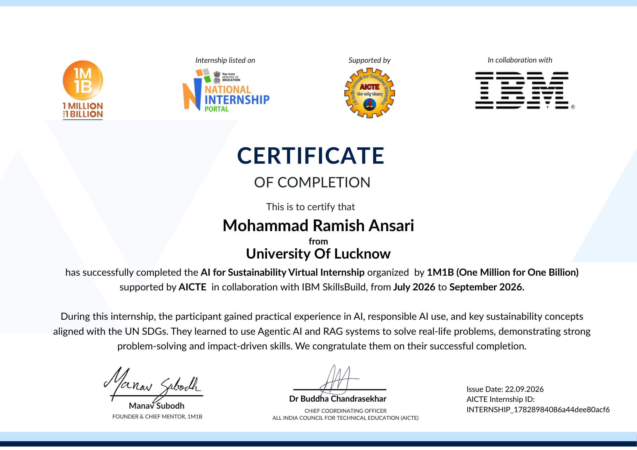
Original AI for Sustainability Virtual Internship completion certificate issued by 1M1B supported by AICTE in collaboration with IBM SkillsBuild, dated 22.09.2026
(AICTE Internship ID: INTERNSHIP_17828984086a44dee80acf6).
ABSTRACT
India generates one of the largest quantities of municipal solid waste in the world, and a large share of it still reaches landfills and open dumps because it is not separated at the point where it is generated — the household. The problem is not only one of indifference. At the moment a resident stands in front of a dustbin holding a milk pouch, a broken charger, a used battery or a soiled cloth, the resident often genuinely does not know which stream the item belongs to. Each wrong guess contaminates a batch of recyclables, increases the load on material recovery facilities, exposes sanitation workers to sharps and chemical residues, and sends organic matter to landfills where it decomposes anaerobically and releases methane.
This report documents the design of SwachhAI, an intelligent waste segregation and sustainable waste management assistant. SwachhAI is proposed as a decision-support concept in which a household member types the name of an item in ordinary language, and the system identifies the appropriate waste stream and returns a short, step-by-step disposal instruction written for the person who generates the waste and for the worker who will handle it. The design recognises eight waste categories — wet, dry, electronic, hazardous, sanitary, textile, construction and demolition, and reject waste — derived from the stream structure of the Solid Waste Management Rules, 2016.
The report explains the technologies involved at an introductory level: the Python programming language, variables and data types, conditional statements, loops, functions, lists and dictionaries, rule-based classification logic, the fundamentals of artificial intelligence, responsible artificial intelligence and the role of digital solutions in sustainability. It presents the conceptual architecture of the proposed system, a classification flowchart, a data flow diagram, an eight-category taxonomy and a documented case study in which three household items — a banana peel, a plastic bottle and an old mobile phone — are traced through the proposed logic to illustrate how the system would behave.
The project aligns primarily with Sustainable Development Goal 12 (Responsible Consumption and Production), and supports Goal 11 (Sustainable Cities and Communities) and Goal 13 (Climate Action). It is important to state clearly that this is a documentation-based academic project. No software, model, application, database or prototype has been built, and every input–output table in this report is an illustrative example of the proposed design rather than the result of an executed application. The contribution of the report is therefore a clear, reviewable and reproducible statement of the problem, the design reasoning and the expected impact of a simple technology-assisted approach to household waste segregation.

Keywords: waste segregation, solid waste management, SwachhAI, rule-based classification, Python, artificial intelligence, responsible AI, sustainability, Sustainable Development Goal 12, circular economy.
ACKNOWLEDGEMENT
I would like to express my sincere gratitude to the Department of Computer Science and Engineering, Faculty of Engineering & Technology, University of Lucknow, for providing me with the academic foundation and the opportunity to undertake this summer internship and to document it in the form of a project report.
I am deeply grateful to my faculty guide, [Name of Faculty Guide], [Designation], Department of Computer Science and Engineering, for the guidance, suggestions and constant encouragement extended during the preparation of this report. I also thank the Head of the Department, [Name of Head of Department], for the administrative support and academic direction that made this work possible.
I sincerely thank 1M1B (One Million for One Billion) for designing and delivering the AI for Sustainability Virtual Internship, the All India Council for Technical Education (AICTE) for supporting the programme through the National Internship Portal, and IBM SkillsBuild for the learning resources and co-certification. The sessions on artificial intelligence, responsible AI, retrieval-augmented generation and agentic systems, together with the sustainability modules, shaped both the project idea and my understanding of how technology can be directed towards a public problem.
I thank the mentors and the 1M1B Academia Team for their feedback during the review points of the internship, and my fellow interns for the discussions that helped me look at the problem from more than one point of view.
Finally, I thank my family for their patience and support throughout the internship period, and my friends and classmates who listened to early versions of this idea and helped me narrow it down to something simple and useful.

(Mohammad Ramish Ansari)
B.Tech. Computer Science and Engineering
University of Lucknow
TABLE OF CONTENTS
CHAPTER 1: INTRODUCTION 1
1.1 Background 1
1.2 The household as the decisive point of intervention 1
1.3 The information gap behind the segregation gap 2
1.4 Motivation for the present study 2
1.5 Scope and nature of this report 2
1.6 Organisation of the report 3
CHAPTER 2: OBJECTIVES OF THE PROJECT 4
2.1 Introduction 4
2.2 Primary objectives 4
2.3 Secondary objectives 4
2.4 Learning objectives 4
2.5 Scope and boundaries 4
CHAPTER 3: OVERVIEW OF 1M1B AND THE INTERNSHIP 6
3.1 About 1M1B 6
3.2 AICTE and the National Internship Portal 6
3.3 IBM SkillsBuild 6
3.4 Internship profile 6
3.5 Structure of the internship 7
3.6 Skills and competencies acquired 7
3.7 Conduct, confidentiality and academic integrity 7
CHAPTER 4: OVERVIEW OF TECHNOLOGIES 8
4.1 Python 8
4.2 Basic classification logic 8
4.3 Rule-based systems 8
4.4 Responsible artificial intelligence 9
4.5 Sustainability and digital solutions 9
CHAPTER 5: PROBLEM STATEMENT 10
5.1 Introduction 10
5.2 The waste problem in Indian cities 10
5.3 Why households fail to segregate 10
5.4 Existing approaches and their limitations 11
5.5 Need for the proposed system 11
5.6 Formal problem statement 12
5.7 Statement of the research question 12
CHAPTER 6: PROPOSED SYSTEM AND CONCEPTUAL DESIGN 13
6.1 The proposed system in one paragraph 13
6.2 Target users 13
6.3 Eight waste categories 13
6.4 Functional requirements 14
6.5 Non-functional requirements 15
6.6 Conceptual system architecture 15
6.7 Classification flowchart 16
6.8 Knowledge base design 17
6.9 Input and output specification 18
6.10 Design constraints 18
CHAPTER 7: DETAILED DESCRIPTION OF THE PROJECT 19
7.1 The waste management cycle 19
7.2 The eight waste categories in detail 19
7.2.1 Wet waste 19
7.2.2 Dry waste 19
7.2.3 Electronic waste 20
7.2.4 Hazardous waste 20
7.2.5 Sanitary waste 20
7.2.6 Textile waste 20
7.2.7 Construction and demolition waste 20
7.2.8 Reject waste 21
7.3 Disposal guidelines by category 21
7.4 Rule design and the classification engine 21
7.5 End-to-end working methodology 22
7.6 Responsible AI considerations in the design 23
7.7 What the proposed system does not do 23
CHAPTER 8: SYSTEM ARCHITECTURE AND WORKING METHODOLOGY 25
8.1 Architectural overview 25
8.2 Interfaces between modules 25
8.3 Data flow 25
8.4 Confidence and uncertainty handling 26
8.5 Failure handling 27
8.6 Design assumptions 27
CHAPTER 9: PRACTICAL CASE STUDY WITH EXAMPLES 28
9.1 Purpose and status of the case study 28
9.2 The scenario 28
9.3 Item 1: banana peel 28
9.4 Item 2: plastic bottle 29
9.5 Item 3: old mobile phone 29
9.6 Consolidated input and output 29
9.7 Uncertain and potentially dangerous items 30
9.8 Further worked examples 30
9.9 Observations from the case study 30
CHAPTER 10: ADVANTAGES AND LIMITATIONS 32
10.1 Introduction 32
10.2 Advantages 32
10.3 Limitations 32
10.4 Mitigation of the identified limitations 33
10.5 Assessment 33
CHAPTER 11: SUSTAINABILITY AND EXPECTED IMPACT 34
11.1 Sustainability context 34
11.2 Environmental impact 34
11.3 Social impact 35
11.4 Economic impact 35
11.5 How the impact would be measured 35
11.6 Responsible deployment 35
CHAPTER 12: CONCLUSION 37
CHAPTER 13: FUTURE SCOPE 38
13.1 Introduction 38
13.2 Near-term directions 38
13.3 Medium-term directions 38
13.4 Long-term directions 38
13.5 Research directions 39
13.6 Concluding remark 39
REFERENCES 40
APPENDICES 42
Appendix A: Evidence of internship learning 42
Appendix B: Checklist of information to be completed before submission 43

CHAPTER 1: INTRODUCTION

1.1 Background
Waste is an unavoidable by-product of human settlement. Every household produces material that it no longer needs: vegetable peels and leftover food, packaging film and paper, batteries and cables, worn-out clothes, sanitary products, broken tiles and much else. In a village or a small town, a large part of this material historically returned to the soil or was reused within the household. In a modern city it becomes a stream that must be collected, transported, processed and finally disposed of, and the cost of doing this correctly rises sharply as cities grow.
India is today one of the largest generators of municipal solid waste in the world. Widely cited compilations of data from the Central Pollution Control Board and the Ministry of Housing and Urban Affairs place annual generation at roughly 62 million tonnes, of which only a fraction is scientifically processed and the remainder is landfilled, dumped or burnt [1], [6]. The composition of Indian household waste is distinctive: a very large proportion, commonly estimated at between fifty and sixty per cent, is organic matter [6], [16].
Table 1.1: Broad characteristics of Indian municipal solid waste as reported in Government of India sources
Characteristic | Widely reported position | Consequence if unmanaged
Annual municipal solid waste generated | Approximately 62 million tonnes [1], [6] | Continuous demand for land, transport and processing capacity
Share generated by households | Largest single source in urban areas [6], [16] | Household behaviour decides the quality of the entire downstream chain
Biodegradable (organic) fraction | Approximately 50–60 per cent of household waste [6] | Anaerobic decay in landfills produces methane
Households segregating at source | A minority; frequently cited at about 30 per cent [1] | Mixed waste reaches every subsequent stage contaminated
Scientific processing | Well below the quantity generated [1], [6] | Recoverable material is lost; landfill volumes keep rising

The policy framework governing this material is already in place. The Solid Waste Management Rules, 2016 make segregation at source a duty of the waste generator and place the responsibility for separate collection on urban local bodies [1]; dedicated rules exist for electronic waste [2], waste batteries [3], construction and demolition waste [4] and plastic waste [5]; and the Swachh Bharat Mission (Urban) 2.0 supports source segregation, material recovery and decentralised processing [7]. The legal machinery, in other words, is not the binding constraint. The binding constraint is behavioural and informational: too many households still put everything into one bag.

1.2 The household as the decisive point of intervention
The household is the point at which waste is created and at which it can still be separated cheaply. Once materials are mixed, separation becomes progressively more expensive and less effective at every later stage. Wet waste soaks into paper and cardboard, oil and food residue coat plastic film, and a single unmarked sharp or a leaking cell can make an entire load unsafe to handle. A municipal collection crew has neither the time nor the protection to sort a mixed bag at the kerbside, and a material recovery facility can only recover what arrives clean enough to be sold.
A small improvement at the household level therefore has a disproportionate effect downstream, and a small failure destroys value that has already been paid for. The case for intervening at the household is both environmental and economic, and it is the reason this project concentrates on the five seconds during which a resident decides which bin to use.

1.3 The information gap behind the segregation gap
It is common to explain poor segregation by saying that people do not care. Observation, and the field evidence summarised in the original internship submission, suggest otherwise: people hesitate. A resident holding a milk pouch, a light bulb, a chips packet or a torn bedsheet has a few seconds at the bin and no reliable way to know the correct stream. The categories used by municipal systems are not those used in ordinary conversation: a citizen may know that e-waste is a separate category and still not know whether a charger cable belongs to it. Guidance, where it exists, is a printed poster or a web page that nobody consults while carrying waste. The gap is therefore one of information and of timing: the knowledge exists, but not at the moment and in the form in which the decision is made.

1.4 Motivation for the present study
This report has its origin in the AI for Sustainability Virtual Internship offered by 1M1B with the support of AICTE and in collaboration with IBM SkillsBuild, which the author completed in 2026. The internship combined structured learning in artificial intelligence, responsible AI, retrieval-augmented generation and agentic AI with a sustained focus on sustainability and the United Nations Sustainable Development Goals. Its final deliverable required each intern to identify a real sustainability problem and to propose an AI-oriented solution to it.
The idea submitted during the internship was SwachhAI — an AI-guided waste segregation and circularity assistant for Indian households [19]. This report takes that idea as its starting point and develops it into a full academic project report: it restates the problem with reference to law and data, explains the technology at a level appropriate to a third-year undergraduate, presents a deliberately simplified conceptual design, and demonstrates the intended behaviour through a documented case study.

1.5 Scope and nature of this report
It is essential to state the nature of this work plainly, because it determines how the report should be read and assessed.
• This is a documentation-based academic project. Its deliverable is a report, not software.
• The system described is a conceptual design. It has not been implemented as an application, a website, a mobile app, a database, an interface or a machine learning model.
• No prototype has been built and no deployment has been carried out. No software testing, unit testing, performance testing or user-acceptance testing has been performed, and none is reported.
• Every input–output table, screen description and worked example in this report is an illustrative example of the proposed logic. The values shown are hand-derived from the stated rules to demonstrate intended behaviour; they are not outputs captured from a running system.
• The project does not claim to determine legal compliance. Disposal guidance is advisory and always defers to the rules of the concerned urban local body.
Chapter 7 and Chapter 9 explain the distinction between the design described here and the broader concept explored during the internship in greater detail.

1.6 Organisation of the report
Chapter 2 states the objectives and boundaries of the project, and Chapter 3 describes 1M1B and the internship. Chapter 4 introduces the relevant technologies and separates what was learned during the internship from what is proposed here. Chapter 5 states the problem and analyses its causes, Chapter 6 presents the proposed system and conceptual design, and Chapter 7 describes the project in detail, including the eight waste categories, the methodology, disposal guidelines and responsible AI considerations. Chapter 8 presents the architecture and data flow and Chapter 9 documents the practical case study. Chapters 10 and 11 discuss advantages, limitations, sustainability and expected impact, and Chapters 12 and 13 present the conclusion and the future scope. References and appendices follow.

CHAPTER 2: OBJECTIVES OF THE PROJECT

2.1 Introduction
The objectives of this project are stated as documentation objectives rather than development objectives, because the deliverable is a report. Each objective below is expressed so that the completed report can be checked against it.

2.2 Primary objectives
1. To study the problem of household waste segregation in urban India and to state it precisely, using the regulatory framework and published waste data as the basis rather than anecdote.
2. To propose a simple, understandable conceptual system — SwachhAI — that accepts the name of a household item and returns its appropriate waste category together with basic disposal guidance.
3. To define a clear eight-category classification scheme covering wet, dry, electronic, hazardous, sanitary, textile, construction and demolition, and reject waste, consistent with the stream structure of the Solid Waste Management Rules, 2016 [1].
4. To present the conceptual architecture, classification logic, flowchart and data flow of the proposed system in a form that another student or reviewer could follow and critique.
5. To demonstrate the intended behaviour of the system through a documented case study with worked examples, clearly identified as illustrative.

2.3 Secondary objectives
1. To explain the relevant technology — Python, basic programming constructs, rule-based classification, artificial intelligence and responsible AI — at a level suitable for an undergraduate in computer science and engineering.
2. To distinguish honestly between the technologies discussed during the internship, the technologies described in the original SwachhAI submission, and the simplified technologies proposed for this conceptual design.
3. To identify the advantages of the approach and, with equal weight, its limitations and the conditions under which it would fail.
4. To relate the work to the United Nations Sustainable Development Goals and to describe a measurable notion of expected impact.
5. To place the work correctly within an academic framework, with references to statutes, standards, agency reports and textbooks.

2.4 Learning objectives
The project also serves a set of internship learning objectives: to move from an open-ended societal problem to a bounded technical statement; to read primary regulatory sources rather than secondary summaries; to design a classification scheme and defend its boundaries; to reason about the ethical consequences of a technical decision, particularly where the safety of sanitation workers is involved; and to communicate a design clearly enough that it can be reviewed by someone who was not present when it was conceived.

2.5 Scope and boundaries
Defining what is out of scope is as important as defining what is in scope, particularly for a project of this kind, where a reader might reasonably expect a software artefact.
Table 2.1: Scope of the project
Within scope | Outside scope
Study of the waste segregation problem and its causes | Development of any software, application, website or mobile app
Eight-category classification scheme with rule definitions | Training or deployment of any machine learning model
Conceptual architecture, flowchart, data flow and interaction diagrams | Creation of a database, an API, or an integration with any external service
Descriptive rule logic expressed in ordinary language | Delivery of source code or executable files of any kind
Documented case study with illustrative worked examples | Prototype development, testing, performance evaluation or deployment
Discussion of advantages, limitations, impact and future scope | Live demonstration, user trials or field measurement

The boundary is deliberate. A three-year undergraduate working alone over a short internship cannot responsibly build, validate and document a production waste-classification system, and pretending otherwise would be both academically dishonest and practically misleading. What can be done well in the time available is to understand the problem thoroughly, design something sensible, and be transparent about its limits. That is what this report attempts.

CHAPTER 3: OVERVIEW OF 1M1B AND THE INTERNSHIP

3.1 About 1M1B
1M1B, read as “One Million for One Billion”, is an Indian non-profit organisation that works at the intersection of emerging technology, employability and sustainable development. Its programmes rest on the idea that young people should be able to use technologies such as artificial intelligence not only to find work but also to address problems in their own communities. It runs structured virtual internships in partnership with industry and government bodies, in which students complete curated learning modules, attend live mentor sessions and submit an applied project at the end.

3.2 AICTE and the National Internship Portal
The All India Council for Technical Education (AICTE) is the statutory body responsible for the planned and coordinated development of technical education in India. Through the National Internship Portal it supports and lists internship opportunities for students of technical institutions, providing a common framework for identification, participation and certification. The internship documented here was supported by AICTE and is listed on that portal, and the completion certificate carries the signature of the Chief Coordinating Officer of AICTE along with that of the Founder and Chief Mentor of 1M1B.

3.3 IBM SkillsBuild
IBM SkillsBuild is a digital learning platform offering curated courses, guided projects and digital credentials. In this internship it supplied the structured e-learning component: modules and learning plans in artificial intelligence, data and professional skills, whose completion is tracked and separately certified. The programme required completion of the assigned guided learning experience and its badges before the final project could be submitted.

3.4 Internship profile
The details below are taken from the internship offer letter and the certificates issued to the student, and are reproduced here for verification. Where two issued documents describe the engagement period in slightly different terms, both statements are recorded exactly as they appear, without reconciliation.
Table 3.1: Verified details of the internship
Field | Detail
Name of intern | Mohammad Ramish Ansari
Institution | University of Lucknow, Lucknow
Programme | Bachelor of Technology (B.Tech.), Computer Science and Engineering
Internship title | 1M1B — AI for Sustainability Virtual Internship
Organised by | 1M1B (One Million for One Billion)
Supported by | All India Council for Technical Education (AICTE), National Internship Portal
In collaboration with | IBM SkillsBuild
Mode of internship | Virtual, online
Period stated in offer letter | 28 July 2026 to 28 August 2026 (6 weeks)
Period stated on completion certificate | July 2026 to September 2026
Completion certificate issue date | 22 September 2026
AICTE Internship ID | INTERNSHIP_17828984086a44dee80acf6
Final project title | SwachhAI — AI for Sustainable Waste Management
Remuneration | Unpaid internship, as stated in the terms of the offer letter

3.5 Structure of the internship
The internship was organised as a sequence of weekly cycles. Each cycle combined guided learning on the SkillsBuild platform with a live session, a mentor interaction and a weekly task or milestone. The programme moved from an orientation phase, through foundations of artificial intelligence and then advanced topics such as large language models, retrieval-augmented generation and agentic systems, into responsible AI and sustainability, and finally into the applied project itself. Certification required participation in the weekly mentor sessions, completion of the weekly tasks and milestones, successful completion of the SkillsBuild learning plan and submission of the final project.

3.6 Skills and competencies acquired
The internship contributed to technical understanding in several areas. It introduced the working of large language models and the reason a model that answers from memory can be unreliable, which motivates retrieval-based grounding; it explained how an agentic system decomposes a task into perceive, decide, act and learn steps; and it required the design of prompts that constrain a model’s behaviour, including explicit refusal rules. It also trained the habit of writing a system disclosure card — stating the task, the knowledge base, the data provenance, the known limits and the failure behaviour of a system before claiming what it can do.
On the sustainability side, the internship required the translation of a local problem into the vocabulary of the Sustainable Development Goals, and the conversion of an intention to help into measurable indicators. On the professional side, it required weekly delivery, written communication and the discipline of documenting work so that it can be reviewed.

3.7 Conduct, confidentiality and academic integrity
The internship offer letter includes a confidentiality clause prohibiting the disclosure of course materials, session content, tools and project-related discussions without prior written approval from 1M1B. This report respects that obligation: it does not reproduce session transcripts, proprietary learning content or the contents of the offer letter beyond the verification details in Table 3.1. What it describes is the author’s own project idea and the public regulatory and scientific literature relevant to it.
Consistent with the programme’s requirement of academic integrity, this report does not present any generated content as measured evidence. All statistics are attributed to public sources, all designs are marked as conceptual, and all example outputs are marked as illustrative.

CHAPTER 4: OVERVIEW OF TECHNOLOGIES

4.1 Python
Python is a high-level, general-purpose programming language designed to be readable. Its syntax is close to ordinary English, indentation rather than braces defines blocks of code, and a very large standard library supports tasks ranging from text handling to data analysis [11]. For a project of this kind, three properties of Python are relevant. First, it is easy to express a decision rule in Python, so a written rule and its implementation look similar. Second, dictionaries allow a small knowledge base to be written directly in the program, without any database. Third, the same constructs scale: the same conditional statement that handles one keyword can handle a thousand.

4.2 Basic classification logic
Classification means assigning an input to one of a fixed set of labels. In the proposed design the labels are the eight waste categories, and the input is a piece of text describing an item. The simplest workable approach is keyword-based scoring: the input is reduced to a set of meaningful words, each word is looked up in the category vocabulary, and the category that matches the most words is selected. The proportion of input words that matched gives a crude but useful confidence value. If no word matches, the item is declared unrecognised rather than guessed.
This approach has a clear profile. It is transparent, because the reason for every answer can be shown. It is cheap, because it requires no training data and no computation beyond string comparison. It is maintainable, because adding an item means adding a word. And it is brittle, because it does not understand synonyms, context or language variation unless those are written into the vocabulary. Chapter 10 states these limitations without softening them.

4.3 Rule-based systems
A rule-based system stores knowledge as a collection of condition–action rules and applies them to an input. In its simplest form, used in this report, the rule set is a lookup table: a keyword belongs to a category, therefore the item mentioned in the input is a candidate for that category. In a fuller form, the rules can include priorities, exclusions and combinations, for example, “if the item is a battery, then the hazard instruction takes precedence over any recyclable material it also contains”.
Table 4.1: Comparison of the two approaches relevant to this problem
Aspect | Rule-based classification (proposed) | Machine learning classification (not proposed)
Knowledge source | Rules written by a person from published guidance | Patterns learned from a labelled dataset
Data requirement | None beyond the rule table | A large, representative, labelled dataset
Explainability | Complete; the matching rule can be displayed | Partial; requires additional explanation techniques
Behaviour on unseen input | Predictable — returns “unknown” | Unpredictable; may return a confident wrong answer
Maintenance | Edit the rule table; the change is immediately visible | Retrain and re-validate; the change is not directly visible
Suitability here | High, for a small, well-defined, safety-sensitive taxonomy | Low at present, given the absence of a curated dataset

For a taxonomy of eight categories in which a wrong answer can put a sanitation worker at risk, the property that dominates is predictability. A system that says “I am not sure” is more useful than a system that is usually right and occasionally confidently wrong without saying so.

4.4 Responsible artificial intelligence
Responsible AI is the practice of designing, deploying and governing AI systems so that they are fair, transparent, accountable, privacy-respecting and safe [13], [14]. The internship treated it as a required component of any proposal rather than an optional appendix. Five concerns are directly relevant to this project.
• Fairness. The system must work for a user who writes in Hindi, in Hinglish, with transliteration or with spelling errors, and must not assume a particular income level, housing type or literacy. A design that only understands formal English silently excludes the users who most need help.
• Transparency. The user should be able to see why a category was chosen, and how confident the system is. A confident wrong answer presented without qualification is worse than no answer.
• Privacy. The system needs only the name of an item. It does not need the user’s name, address, location or household data. Any design that collects more than it needs is taking an unnecessary risk with someone else’s information.
• Safety and human oversight. For hazardous, sanitary and electronic items, the guidance must prioritise the safety of the person who will handle the waste, and must direct the user to authorised channels and to the concerned municipal body rather than assert a legal requirement.
• Honesty. The system must not present estimates as measurements, must not exaggerate environmental benefit, and must state its own limitations.

4.5 Sustainability and digital solutions
Sustainability, in the formulation of the 2030 Agenda, means meeting present needs without compromising the ability of future generations to meet theirs, expressed through seventeen Sustainable Development Goals [17]. Digital solutions contribute in two ways: by substituting information for material — a correct instruction delivered to a phone replaces a printed poster and a lost recyclable — and by making behaviour visible. The internship required a sustainability project to name the specific goal and target it addresses and to define how the claimed change would be measured, a requirement that shapes Chapter 11.

CHAPTER 5: PROBLEM STATEMENT

5.1 Introduction
This chapter states the problem in two forms. Sections 5.2 to 5.5 describe it in narrative and analytical terms; Section 5.6 compresses it into a formal statement. The analysis draws on the stream structure and generator duties defined in the Solid Waste Management Rules, 2016 [1], on national waste assessments [6], [16], and on the field-research synthesis recorded in the original internship submission [19].

5.2 The waste problem in Indian cities
A city’s waste system has six stages: generation, segregation, collection, transport, processing and disposal. Each stage depends on the one before it. When segregation is weak, collection crews must handle mixed material, transport volumes rise because wet waste adds weight, processing becomes harder because composting requires clean organics and recycling requires clean dry material, and disposal volumes grow because less has been recovered. A failure at the first stage is paid for at every later stage, in money, in land and in health.
The most serious consequence is atmospheric. When organic waste is buried rather than composted it decomposes without oxygen and releases methane, a gas with a far higher short-term warming potential than carbon dioxide [9]. Since organic matter forms the majority of Indian household waste [6], the ordinary mixed dustbin is, at national scale, a methane generator. A second consequence concerns material: recyclables that arrive wet or oily are rejected, so the energy already invested in them is lost. A third concerns people: workers handling unseparated waste meet broken glass, needles, soiled sanitary products and leaking batteries without warning and often without protection.
Table 5.1: Consequences of poor household segregation
Consequence | Mechanism | Who bears the cost
Landfill methane | Organic waste buried instead of composted decays anaerobically | Society at large, through climate change
Loss of recyclables | Wet and oily contamination makes dry material unsaleable | Recyclers, scrap dealers, municipal revenue
Higher collection cost | Mixed waste is heavier and bulkier; routes take longer | Urban local body, and therefore the taxpayer
Worker injury and exposure | Sharps, chemicals and soiled sanitary waste are hidden in mixed bags | Sanitation workers and their families
Air pollution from burning | Dumps and landfills catch fire; waste is burnt informally | Nearby residents, particularly children and the elderly
Loss of public confidence | Residents who do segregate see their effort undone during collection | The credibility of the entire civic system

5.3 Why households fail to segregate
The immediate explanation offered most often is indifference. A closer look suggests that hesitation, not indifference, is the dominant cause. Four mechanisms recur.
1. Category mismatch. Municipal systems use stream names such as dry waste, wet waste, domestic hazardous waste and sanitary waste. Ordinary language uses item names — a packet, a tube light, a diaper, a charger. The resident must translate between two vocabularies at the bin, without help.
2. Decision pressure. The decision is made in a few seconds, under time pressure, often while holding something unpleasant. Any design that requires the resident to consult a poster, open a web page or remember a rule will fail at this point.
3. Ambiguous items. Many everyday objects genuinely straddle categories. A milk pouch is plastic but food-contaminated; a compact fluorescent lamp is both electronic and hazardous; a medicine strip is plastic, foil and chemical residue at once. Uncertainty produces guessing.
4. Absence of feedback. Nothing tells the resident whether the guess was right. Without feedback, an incorrect habit persists indefinitely, and there is no visible benefit to reinforce the correct one.
Table 5.2: Root-cause analysis of the observed symptoms
Observed symptom | Underlying root cause | Source of evidence
One bag used for everything at home | Residents lack per-item knowledge at the exact moment of the decision | Field interviews and national source-segregation rates [1], [19]
Recyclables rejected at the recovery facility | Wet waste soaks dry recyclables; oil and food residue are the principal contaminants | Facility operations guidance [7], [16]; worker accounts [19]
Sanitation worker injuries | Sharps, lamps, batteries and chemicals are hidden unmarked in mixed bags | Worker interviews recorded in the internship submission [19]
Landfill methane | Half or more of household waste is organic and rots anaerobically when mixed | Composition studies [6], [16]; IPCC assessments [9]
Households that segregate stop doing so | Effort appears to be wasted when collection mixes the streams again | Reported in the internship field synthesis [19]

5.4 Existing approaches and their limitations
Several approaches already exist, and none of them is sufficient on its own.
Table 5.3: Existing approaches and their limitations
Approach | What it does well | Why it is not sufficient
Printed posters and awareness drives | Reach many people at low cost; create general awareness | Not available at the moment of decision; easily forgotten; not item-specific
Two-bin or three-bin systems provided by the local body | Establish a physical structure for segregation | Do not tell the user which bin a particular item belongs to
Municipal websites and helpline numbers | Authoritative and legally grounded | Require the user to search a document; rarely used at the bin
Manual sorting at the recovery facility | Recovers some material regardless of household behaviour | Expensive; exposes workers to hazards; cannot undo contamination
Informal scrap-dealer networks | Highly effective for high-value dry waste | Do not cover low-value or hazardous fractions; depend on price
Social pressure and penalties | Can improve compliance where enforcement is possible | Difficult to enforce at household level; may create resentment rather than understanding

The gap that remains is narrow and specific: an item-level answer, available instantly, in the language the user actually speaks, that also tells the user how to prepare the item so that it remains useful and safe after it leaves the house.

5.5 Need for the proposed system
The proposed system addresses exactly that gap and nothing more. It does not replace municipal collection, regulation, material recovery facilities or the informal recycling economy; it removes the most common local cause of failure — an uncertain resident in front of a bin — by supplying a category and a short instruction at the moment of disposal. Three properties make the problem suited to computation: the decision is a classification problem with a small label set; the knowledge required is finite, documented and public, so nothing need be learned from data; and the output is short and checkable, so the design can be evaluated on paper without a running program.

5.6 Formal problem statement
Given an everyday description of a household item supplied by a resident in ordinary language, determine the appropriate waste stream among the eight defined categories, express the degree of certainty in that determination, and return a short sequence of disposal instructions that is safe for the person handling the waste and consistent with the segregation duties placed on waste generators by the Solid Waste Management Rules, 2016. Where the determination is not sufficiently certain, the system must refuse to guess, must say so explicitly, and must direct the user to the concerned urban local body.
The problem as stated has three properties that shape the solution: it is safety-critical for a subset of inputs, which requires special handling rules to override ordinary recycling advice; it is open-vocabulary, since users will type anything, which requires an explicit unrecognised path; and it is locally variable, since container colours and collection arrangements differ between urban local bodies, which requires the guidance to be advisory and to defer to local rules.

5.7 Statement of the research question
The report is organised around a single question: how might a simple, transparent and verifiable computer-based assistant help a household put each item into the correct waste stream, without requiring a trained model, a large dataset or a continuous network connection, and without ever presenting a guess as a fact?

CHAPTER 6: PROPOSED SYSTEM AND CONCEPTUAL DESIGN

6.1 The proposed system in one paragraph
SwachhAI is proposed as a household waste segregation assistant. A resident types the name of an item — “banana peel”, “plastic bottle”, “old mobile phone” — into a simple text field. The system reduces the phrase to meaningful keywords, compares them against a knowledge base organised around eight waste categories, selects the strongest match, records how confident it is, and returns a short card containing the category, the confidence level, the container or channel, and three or four disposal steps. If no reliable match is found it says so and advises the user to follow the guidance of the concerned urban local body. If the item is hazardous, sanitary or electronic, the guidance changes from recycling advice to safe-handling instructions.
That is the whole system. Its simplicity is deliberate: the design is small enough that every rule can be read, understood and criticised by a person, which is the property that makes a conceptual design reviewable in an academic setting.

6.2 Target users
The design is not aimed at a single type of user. Table 6.1 describes the four groups whose needs shaped it, and what each of them would consider a successful outcome. The fourth group is included deliberately: the person who handles the waste after it leaves the household is the ultimate beneficiary of correct segregation, and the design is written partly for that person’s safety.
Table 6.1: Target users of the proposed system
User group | Situation and difficulty | How the design serves them | Success signal
Household head or homemaker | Manages daily kitchen and household disposal; short of time at the bin | Instant per-item answer; instructions phrased as actions, not categories | Correct sorting observed in a household audit
Student or hostel resident | Shared rooms and shared bins; little space for separate containers | Short quick-reference answers for hostel items such as food packets, chargers and notebooks | Regular use; less mixing in hostel bins
Sanitation and collection worker | Handles unmarked sharps, acids and broken glass with limited protection | Guidance that tells the generator to wrap, mark and hand over separately | Fewer injury and exposure incidents
Urban local body and ward staff | Receives contaminated loads; has little item-level information | Cleaner inbound streams; aggregate understanding of common mistakes | Higher purity of the dry stream

6.3 Eight waste categories
The classification scheme has eight categories. The structure follows the stream logic of the Solid Waste Management Rules, 2016, which separate biodegradable, non-biodegradable, domestic hazardous and sanitary waste at source and which treat construction and demolition waste under a separate regulation [1], [4]. Electronic waste is separated because it is governed by its own rules and has an established take-back channel [2]; textile waste because it follows a reuse-first logic; and reject waste because there is genuinely no correct destination for some materials, and pretending otherwise misleads the user. Figure 6.1 shows the eight categories with the kind of material each contains.
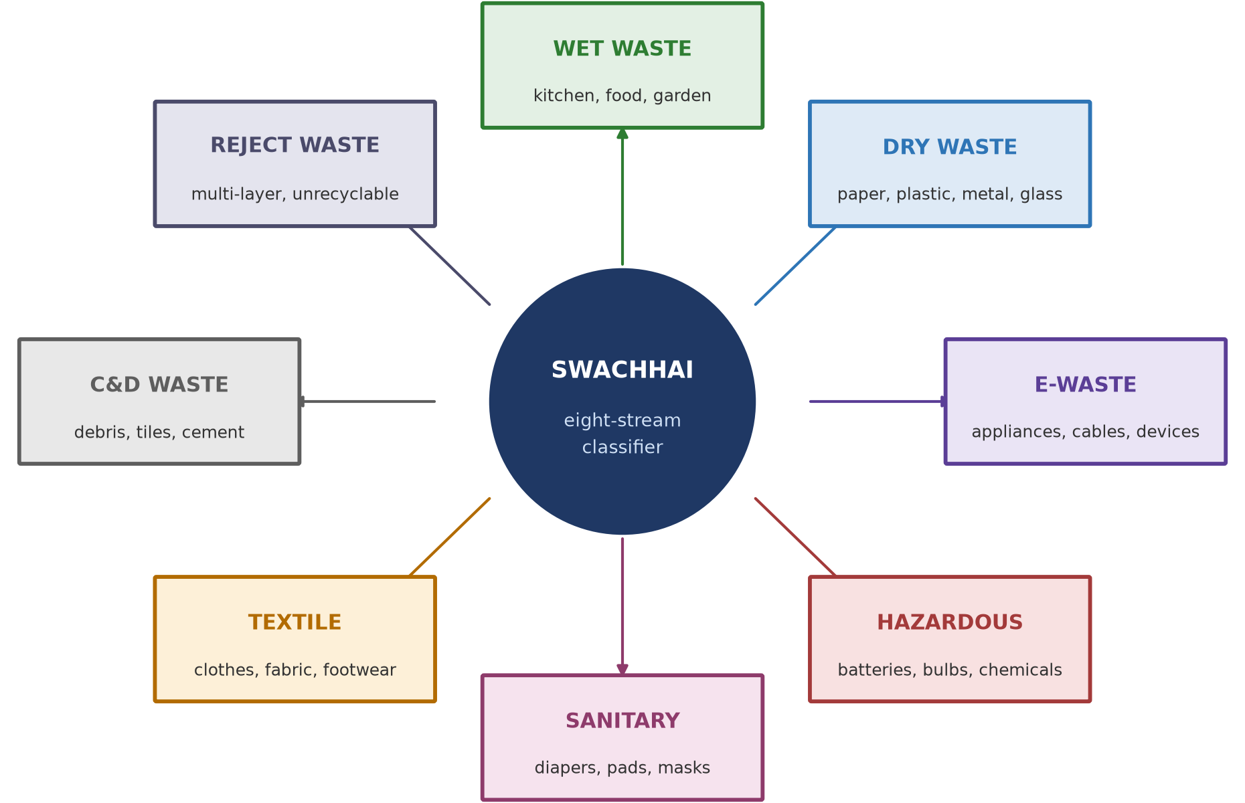
Fig. 6.1: The eight waste categories recognised by the proposed SwachhAI classifier (conceptual diagram)
Table 6.2: Overview of the eight waste categories
No. | Category | Typical household content | Primary handling route
1 | Wet Waste | Vegetable peels, cooked food leftovers, tea leaves, garden clippings, egg shells | Green bin; home or community composting
2 | Dry Waste | Newspaper, cardboard, plastic bottles and film, metal cans, glass jars, packaging | Blue bin, or sale to a scrap dealer after cleaning
3 | E-Waste | Chargers, cables, headphones, old phones, small appliances, circuit boards | Authorised e-waste collection point or producer take-back
4 | Hazardous Waste | Used batteries, compact fluorescent lamps, paints, solvents, pesticides, expired medicines | Authorised collection drive or municipal facility; never the general bin
5 | Sanitary Waste | Sanitary pads, diapers, tampons, used masks, bandages | Wrapped and marked separately; handed over as specified by the local body
6 | Textile Waste | Worn clothes, bed linen, towels, footwear, fabric off-cuts | Reuse or donation first; then textile recycling
7 | Construction and Demolition Waste | Broken tiles, cement lumps, bricks, plaster, sanitaryware | Separate collection by the local body or an authorised C&D facility
8 | Reject Waste | Multi-layer laminated film, soiled non-recyclable material, composites, sweepings | Residual bin; only what cannot be recovered

6.4 Functional requirements
Table 6.3: Functional requirements of the proposed system
ID | Requirement | Rationale
FR-1 | The system shall accept a free-text item description from the user. | Users describe items in their own words, not in the vocabulary of the system.
FR-2 | The system shall normalise the input before matching it. | Letter case, punctuation and spelling variation must not change the answer.
FR-3 | The system shall map the normalised input to exactly one of the eight categories. | A single, unambiguous answer is what the user needs at the bin.
FR-4 | The system shall report the degree of confidence in the answer. | The user is entitled to know when the answer is weak.
FR-5 | The system shall return an ordered set of disposal steps with the category. | The category alone does not tell the user how to prepare the item.
FR-6 | The system shall return a special-handling instruction for hazardous, sanitary and electronic items. | These items can injure the person who handles the waste.
FR-7 | The system shall decline to classify an item it does not recognise and shall advise the user to consult the local body. | A refusal is safer than a fabricated answer.
FR-8 | The system shall not require any personal information from the user. | The task can be completed without identifying the user.

6.5 Non-functional requirements
The non-functional requirements concern the quality of the interaction rather than its content. A response should be effectively instantaneous, because the user will not wait; every category decision must be explainable in one sentence, so that the user can see why the answer was given; the knowledge base must be editable by a non-programmer, so that a local body can maintain it; the design must function without a network connection; the guidance must be written at a basic reading level; no user data may be stored or transmitted; and any statement of a legal or regulatory position must be attributed and marked as advisory.

6.6 Conceptual system architecture
The architecture is described as five layers. The use of layers is not decoration: it separates the parts of the system that change for different reasons. The user interface changes when the audience changes; the knowledge base changes when a rule is amended; the decision layer changes when the policy about uncertainty changes. Keeping them apart means that a change in one does not force a change in the others.
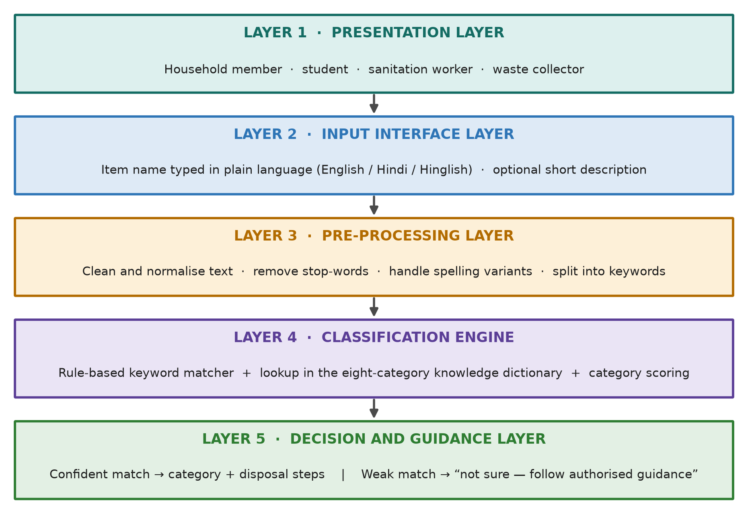
Fig. 6.2: Conceptual layered architecture of the proposed SwachhAI assistant
Layer 1 identifies who is asking: a household member, a student, a sanitation worker or a collector. Layer 2 is the input interface, deliberately minimal — a single text field. Layer 3 cleans the text and reduces it to meaningful keywords. Layer 4 matches keywords against the eight-category knowledge base and produces a scored result. Layer 5 decides whether the result is strong enough to show, assembles the disposal steps, and inserts the special-handling block where the category requires it.
The separation between Layer 4 and Layer 5 is the most important decision in the architecture. Deciding what an item is and deciding what to tell the user about it are different judgments with different failure modes: a classifier can be quite sure that a substance is a solvent while the correct advice is still “do not put this in any bin; contact the municipal facility”. Keeping them apart allows the safety policy to be written once and applied to every category equally.

6.7 Classification flowchart
Figure 6.3 traces the decision from the moment an item name is received to the moment guidance is displayed. The flow contains three decision points, and each of them exists to prevent a particular failure.
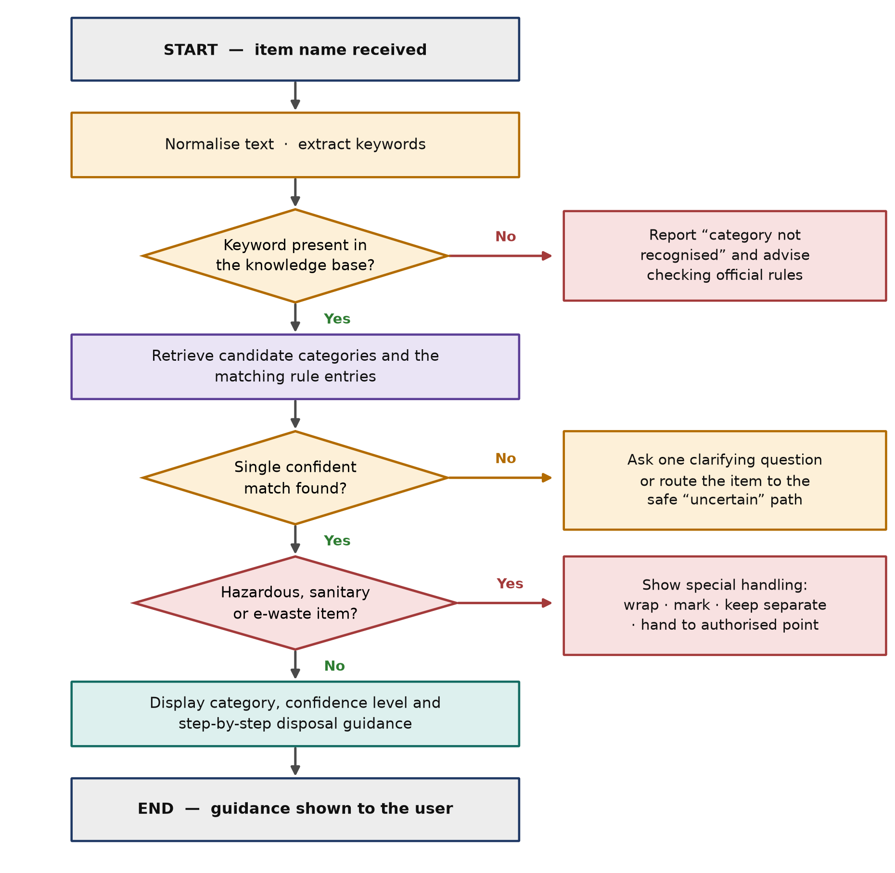
Fig. 6.3: Waste classification flowchart of the proposed system (conceptual)
1. The first decision point asks whether any keyword from the input appears in the knowledge base. If none does, the system must not force the item into a category. It reports that the item is not recognised and advises the user to check the official rules.
2. The second decision point asks whether exactly one category has emerged as the strongest match. Where two categories are nearly tied — a composite item such as a medicine strip, for instance — the system asks one clarifying question or routes the item to the cautious path.
3. The third decision point asks whether the matched category is hazardous, sanitary or electronic. If it is, the ordinary recycling instruction is replaced by a wrap-mark-separate instruction, and the user is directed to an authorised collection channel.

6.8 Knowledge base design
The knowledge base is the substance of the system. It is conceived as a table with one row per category and fields for the category, keywords, collection channel, disposal steps and special handling, and it is populated from published guidance rather than from intuition. Four principles govern its construction.
• One item, one home. Every item in the vocabulary belongs to exactly one primary category. Where an item genuinely has two aspects, the safety-relevant category takes precedence and the other aspect is mentioned in the guidance text.
• Everyday words first. The vocabulary records the words people actually use — “doodh ka packet”, “tube light”, “chips wrapper” — not only the formal names used in regulation.
• Instructions as actions. Each step is a short imperative sentence describing something the user can physically do: rinse, dry, flatten, wrap, tape the terminals, hand over separately.
• No unsupported claims. Where a step depends on local practice — the colour of the bin, the day of collection — the text says so and refers the user to the local body.
The worked examples in Chapter 9 illustrate how the proposed knowledge base would be used. They are examples of the design, not a complete or authoritative reference.

6.9 Input and output specification
The input is a single free-text string naming one household item, entered in English, Hindi or Hinglish. No personal information is required or requested. On a confident match the output is the category name, the confidence level, the container or channel, three to four ordered disposal steps and one short factual note; on special handling it is the same with a wrap-mark-separate instruction placed first and a direction to an authorised collection point; and on failure it is an explicit statement that the item was not recognised, with advice to consult the concerned urban local body. The output is presented as short labelled lines suitable for a small screen, without jargon or category codes.

6.10 Design constraints
Four constraints were accepted at the outset. The system must be usable by a person who has never seen it, without training; it must not depend on the internet, because nobody waits for a page to load at a dustbin; it must not require a labelled dataset, because none exists in a form an undergraduate project could responsibly use; and it must make no claim that requires measurement it cannot perform, which is why the design reports categories and instructions but not tonnage or emission savings.

CHAPTER 7: DETAILED DESCRIPTION OF THE PROJECT

7.1 The waste management cycle
To explain the design it is first necessary to describe the system into which it fits. Municipal solid waste management is conventionally described as a chain of six stages, and the proposed assistant operates at the very first of them.
1. Generation. Waste is created in households, shops, offices and institutions. The generator decides what to do with each item, and that decision is the object of this project.
2. Segregation. Waste is separated at source into streams. The Solid Waste Management Rules, 2016 place this duty on the generator and require the local body to collect the streams separately [1].
3. Collection. Waste is transferred from the household or a community bin to a vehicle. Mixed waste at this stage makes every later stage harder.
4. Transportation. Waste is moved to a transfer station or a processing facility. Wet waste adds weight and leachate; unseparated sharps add risk to the crew.
5. Processing. Organic waste is composted, vermicomposted, digested or refused-derived-fuelled; dry waste is sorted and baled at a material recovery facility; e-waste and hazardous waste go to authorised recyclers [2], [3].
6. Disposal. Only the residue that cannot be recovered should reach a sanitary landfill. In practice a far larger fraction does, which is the central problem this report addresses.

7.2 The eight waste categories in detail
Each category below is described in terms of what belongs to it, what does not, and why the boundary is drawn where it is. The boundaries are the substantive part of the design; a list of category names on its own is of little use.

7.2.1 Wet waste
Wet waste, also called biodegradable, organic or green waste, is material that decomposes biologically: peels, food leftovers, tea and coffee grounds, egg shells, garden clippings and leaves. It forms the largest single component of Indian household waste [6]. It belongs in the green bin, and its preferred destination is composting, vermicomposting or biomethanation, because composting returns carbon to the soil while landfilling the same material produces methane [9]. The boundary users most often get wrong is packaging: a food packet with residue inside is not wet waste. The correct instruction is to empty the peels into the green bin and treat the packaging separately.

7.2.2 Dry waste
Dry waste is non-biodegradable material that is, in principle, recoverable: paper and cardboard, plastic bottles, containers and film, metal cans, glass bottles and clean packaging. Its value depends almost entirely on cleanliness. A rinsed, dried and flattened bottle is a saleable commodity; the same bottle containing a spoonful of curd contaminates a whole bale. The plastic waste rules require source segregation and discourage single-use plastic, and the resin identification codes help identify polymer type [5], [10]. The boundary users most often get wrong is that between dry and reject waste: multi-layer laminated film, such as the metallised inner layer of a chips packet, is not economically recyclable in most Indian facilities, and placing it in dry waste lowers the quality of the entire load.

7.2.3 Electronic waste
Electronic waste consists of discarded electrical and electronic equipment: phones, chargers, cables, headphones, small appliances, circuit boards and information technology equipment. It is regulated under the E-Waste (Management) Rules, 2022, which establish producer responsibility and channel waste to authorised dismantlers [2]. It carries both valuable material, such as copper and aluminium, and hazardous material, such as lead, so informal dismantling is dangerous and authorised recycling essential. It also carries data, which is why any e-waste guidance must include a data-deletion step. The boundary most often confused is that between e-waste and hazardous waste: a compact fluorescent lamp is electrical, but its mercury content makes the safety instruction decisive [2], [6].

7.2.4 Hazardous waste
Domestic hazardous waste is the fraction that can injure people or damage the environment if it enters the ordinary stream: batteries, compact fluorescent lamps, paints and solvents, pesticide containers, corrosive cleaners and expired medicines. The Solid Waste Management Rules, 2016 require it to be kept separate and handed to the authority or an authorised agency, and the Battery Waste Management Rules, 2022 route waste batteries to take-back systems with producer responsibility obligations [1], [3]. Three instructions are standard: never place the item in any ordinary bin; wrap, contain and mark it; and hand it over at an authorised point. For lithium batteries the terminals are taped, because a short circuit in a collection vehicle can start a fire [3]. Where an item is both recyclable and hazardous, the hazardous instruction wins.

7.2.5 Sanitary waste
Sanitary waste comprises used sanitary pads, tampons, diapers and nappies, and, since recent years, used masks, gloves and bandages. The Solid Waste Management Rules, 2016 require it to be wrapped in the material provided by the manufacturer or in paper and handed over separately, so that it need not be touched by collection staff [1]. This is guidance written for the handler rather than for the material: nothing about a used pad is valuable, but the way it is presented determines whether the person collecting it is exposed. The word “wrap” is therefore the operative instruction and the design places it first. Sanitary waste is sometimes treated as wet waste because it is organic; it must not be, because of the infection risk.

7.2.6 Textile waste
Textile waste includes worn or torn clothing, bed linen, towels, curtains, footwear, bags and fabric off-cuts. Its handling follows a hierarchy that differs from the other categories: reuse first, then repair, donation and recycling, and only then disposal. A wearable shirt has far more value as a shirt than as fibre. Recycling recovers material for wiping cloths, insulation and regenerated yarn, but it requires the material to be clean and dry; a soiled cloth is a reject. A large informal network of collectors already handles reusable textiles, and the design points users to that channel before mentioning recycling at all.

7.2.7 Construction and demolition waste
Construction and demolition waste comprises bricks, tiles, cement and concrete lumps, plaster, rubble, sanitaryware and broken ceramics generated by household repair and renovation. It is governed by the Construction and Demolition Waste Management Rules, 2016, which require the waste to be segregated on site and delivered to a processing facility, and which prohibit disposal in ordinary bins, on open land, in water bodies or by burning [4]. The most important message for a household is negative: this material must not enter the household waste stream at all, because a single bag of rubble can block a collection vehicle and damage a composting or sorting facility.

7.2.8 Reject waste
Reject waste is the honest category: what remains after every recoverable fraction has been removed — multi-layer and metallised laminates, composite packaging, heavily soiled material and thermocol. Naming it prevents a common error in awareness material, which is to imply that every item is recyclable if only it is sorted. That implication is false, and it transfers responsibility to the citizen for a problem that lies with product design. What the user can do is limited: keep it dry and separate so that it does not contaminate recoverables, and never burn it, since open burning of chlorinated plastics releases hazardous compounds.

7.3 Disposal guidelines by category
Table 7.1 consolidates the guidance into a single reference. It is the closest thing in this report to the output the proposed system would produce, and it is presented here as documentation of the design, not as a substitute for local rules.
Table 7.1: Consolidated disposal guidance by category
Category | Container or channel | Preparation before handover | Must never
Wet Waste | Green bin; home or community compost | Drain excess liquid; keep covered | Be mixed with plastic, glass or paper
Dry Waste | Blue bin; scrap dealer; recovery facility | Rinse, dry, flatten; bundle similar material together | Contain food residue or liquids
E-Waste | Authorised e-waste point; producer take-back | Delete data; keep accessories together; do not open the device | Be sold to an unauthorised dismantler or put in a dry bin
Hazardous Waste | Authorised collection drive; municipal facility | Tape battery terminals; keep bulbs intact; wrap and mark | Enter any ordinary bin; be burnt or broken
Sanitary Waste | Wrapped bag handed over separately | Wrap in paper or a newspaper; mark the bag | Be flushed, or mixed with wet or dry waste
Textile Waste | Donation, reuse or textile recycler | Wash and dry; repair if wearable | Be thrown away while still wearable
C&D Waste | Local body or authorised C&D facility | Store separately; keep dry; arrange transport | Be placed in household bins or dumped on open land
Reject Waste | Residual bin | Remove recoverables; drain and dry | Be burnt in the open

7.4 Rule design and the classification engine
The rules are written in a form that a non-programmer can read and an examiner can check. Each rule states a keyword or set of keywords, the category to which the keyword points, and, where relevant, a precedence condition. Figure 7.1 shows how a single input passes through the engine.
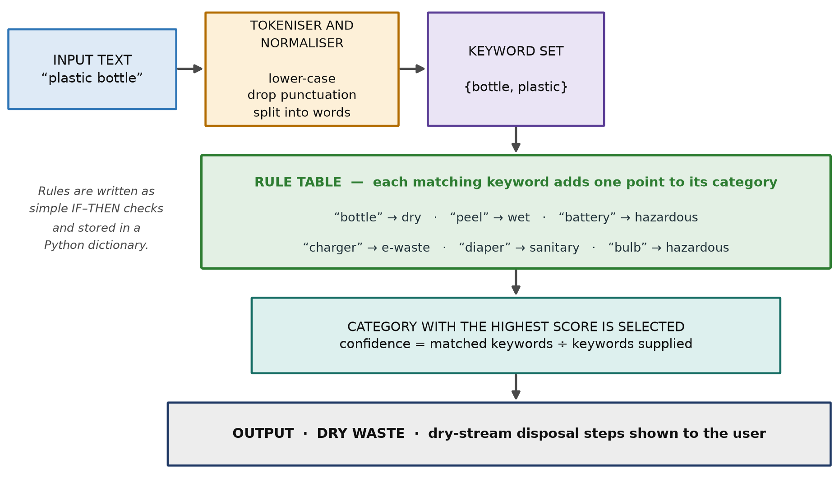
Fig. 7.1: Illustrative internal logic of the rule-based classifier (conceptual)
The engine performs five steps for every input. It normalises the text by converting it to lower case, removing punctuation and splitting it into words, and discards words that carry no information. It scores each of the eight categories by counting how many remaining words appear in that category’s vocabulary. It selects the highest-scoring category and computes a confidence value as the proportion of input words successfully matched. Finally it checks the selected category against the special-handling flag and assembles the output card accordingly.
Precedence rules are stated separately because keyword scoring alone cannot express them. Three are defined: a hazardous keyword overrides any recyclable-material keyword, so “old battery” is hazardous although it contains metal; a sanitary keyword overrides a wet-waste keyword, so a soiled diaper is sanitary although it is organic; and a construction keyword overrides a dry-waste keyword, so a broken ceramic tile is C&D waste although it is inert.

7.5 End-to-end working methodology
Figure 7.2 summarises the six stages of the interaction. The stages are described in words below so that the design can be followed without reference to any program.
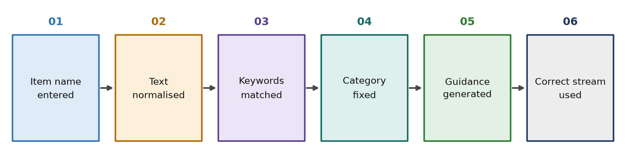
Fig. 7.2: End-to-end workflow of the proposed conceptual system
Table 7.2: Step-by-step working methodology
Step | What happens | Design rule applied
1. Input | The user enters the name of the item in ordinary language. | One item per query; no personal data requested.
2. Normalise | The text is lower-cased, punctuation is removed and the phrase is split into words; common spelling variants are mapped to a standard form. | Equivalent inputs must produce equivalent answers.
3. Extract | Words that carry no information are discarded; the remaining keywords form the query set. | Only meaningful words influence the answer.
4. Score | Each category receives one point for every keyword found in its vocabulary. | Scoring is additive and auditable.
5. Select | The highest-scoring category is selected; confidence is computed from the proportion of keywords matched. Precedence rules are applied. | Safety categories take precedence over recoverable-material categories.
6. Guide | The category, confidence and ordered disposal steps are assembled into a short card; where the category requires it, the special-handling block is inserted. If no category reached the threshold, the refusal message is returned instead. | Never present an uncertain answer as certain; never omit the safety instruction.

7.6 Responsible AI considerations in the design
Because the proposal is a decision-support system that touches safety, the responsible AI analysis is part of the design rather than a commentary on it. Table 7.3 states each principle together with the specific design decision that implements it.
Table 7.3: Responsible AI principles and their implementation in the design
Principle | Design decision that implements it
Fairness and inclusion | Input is accepted in English, Hindi and Hinglish, with common spellings and transliterations recorded in the vocabulary. The interface is text-only, works on a basic phone, and assumes no prior knowledge of waste terminology.
Transparency | Every answer shows the category, the confidence level and the matched keywords, so the user can see why the answer was given.
Honest refusal | A confidence below the display threshold produces an explicit statement that the item was not recognised, rather than the nearest guess.
Privacy | No name, address, location, photograph or identifier is requested, stored or transmitted. The design has no database and no network component.
Safety precedence | Hazardous, sanitary and electronic categories trigger a wrap-mark-separate instruction that overrides ordinary recycling advice.
Human oversight | The guidance is advisory. For hazardous material and for any legal question, the user is directed to the concerned urban local body.
Accountability | The knowledge base is documented, attributable to published sources, and open to review; every edit can be traced to a reason.
No greenwashing | The design reports categories and instructions only. It makes no tonnage, emission or savings claim that it cannot demonstrate.

One further consideration is easy to overlook. The guidance is something that other people will act on behalf of the user — the collector who lifts the bag, the sorter who opens it, the worker who handles it at the recycling unit. A design that only optimised for the convenience of the household would be unfair to those workers, which is why the instruction sequence places wrapping, taping and marking before any advice to recycle.

7.7 What the proposed system does not do
A design is defined as much by its exclusions as by its features, and the following exclusions are intentional.
• It does not look at the waste. There is no camera, no image recognition and no material sensing; it works only from the words the user supplies.
• It does not learn. The knowledge base changes only when a person changes it, and every change is reviewable.
• It does not determine legal compliance. It states advisory guidance and defers to the local body on all regulatory questions.
• It does not measure anything. It makes no claim about how much waste has been diverted or how much emission has been avoided.
• It does not replace collection, processing or the informal recycling economy. It addresses only the moment at which the household decides what to do with an item.

CHAPTER 8: SYSTEM ARCHITECTURE AND WORKING METHODOLOGY

8.1 Architectural overview
The architecture described in Chapter 6 is presented here at the level of modules and interfaces, so that the responsibilities of each part and the boundaries between them are explicit. The system is decomposed into six processing modules and two data stores. No module depends on any external service, and every interface between modules is a simple value passed from one step to the next.
Table 8.1: Module decomposition of the proposed system
Module | Responsibility | Input | Output
M1 — Input handler | Receives the raw text entered by the user; enforces one item per query; rejects empty input | User text | Raw item string
M2 — Normaliser | Lower-cases the string, removes punctuation, splits it into words and maps known spelling variants to a standard form | Raw item string | Clean word list
M3 — Keyword extractor | Removes words that carry no information and returns the meaningful keyword set | Clean word list | Keyword set
M4 — Scorer | Counts keyword matches against each of the eight category vocabularies | Keyword set | Score for each category
M5 — Selector | Selects the highest-scoring category, applies precedence rules and computes the confidence value | Category scores | Category and confidence
M6 — Guidance composer | Assembles the output card: category, confidence, container, ordered steps, safety block or refusal message | Category and confidence | Guidance card

8.2 Interfaces between modules
The interfaces are deliberately narrow. Only the input handler sees text the user typed, only the scorer sees the knowledge base, and only the guidance composer sees the safety templates. A fault in text handling therefore cannot silently alter a disposal instruction, and changing the wording of a safety instruction cannot change a classification result. Where one output may protect a worker from injury, keeping the safety wording in one place is not good practice but a requirement.

8.3 Data flow
Figure 8.1 presents the same architecture as a data flow diagram, with the household member and the sanitation worker shown as external entities and the knowledge base and guidance library shown as data stores. The diagram shows a single process, numbered 1.0, because at this level of abstraction the classification is one transformation: an item name in, a guidance card out.
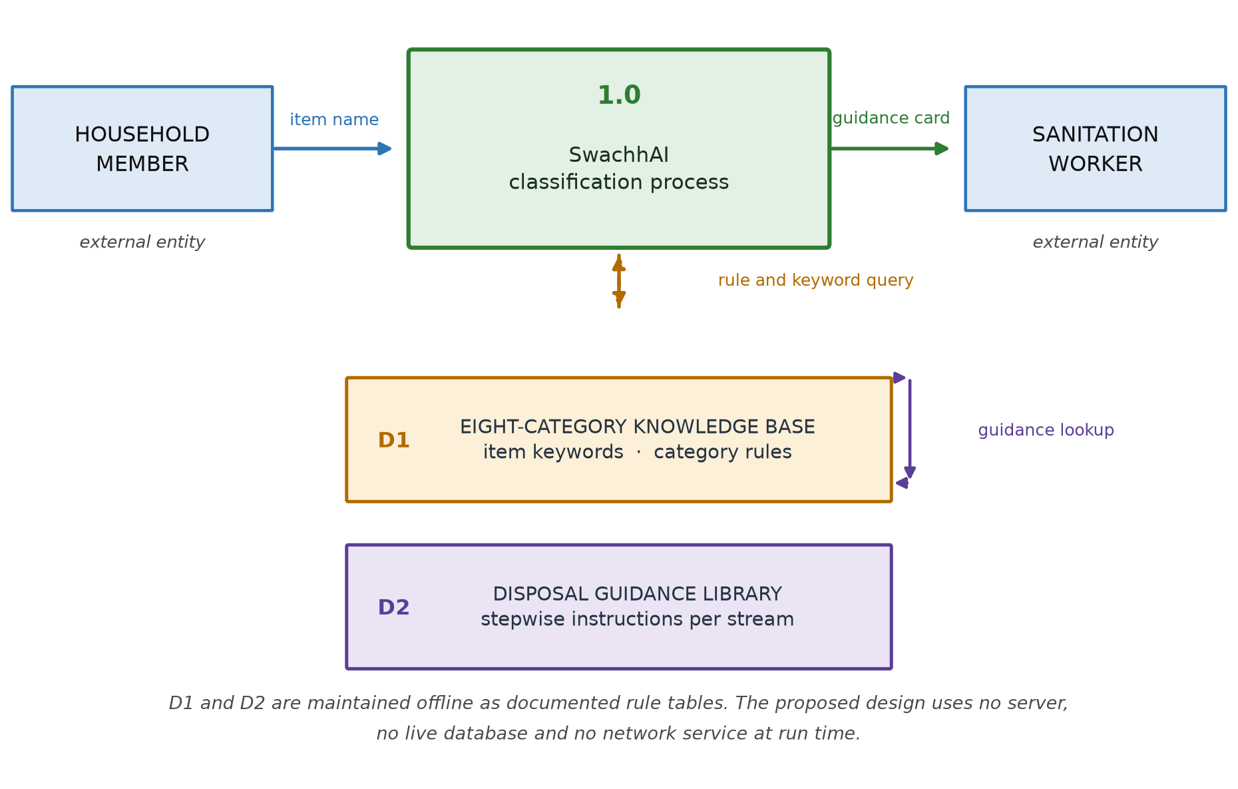
Fig. 8.1: Data flow diagram (level 0 / level 1 view) of the proposed system
The two data stores are drawn as stores rather than as part of the process to make a point about the design: the knowledge base and the guidance library are reference data, maintained outside the processing path and reviewed before release. In the proposed design they are documented tables. They are not a database, they are not queried over a network, and they hold no user information.

8.4 Confidence and uncertainty handling
Confidence is the most delicate part of the design, because it is the mechanism by which the system decides whether to speak or to stay silent. The proposed treatment is summarised below. The thresholds are design parameters chosen for explanation and would be fixed only after review with waste-management practitioners.
Table 8.2: Proposed handling of confidence levels
Situation | Displayed behaviour | Reason
All supplied keywords match one category | Category shown with a high confidence indicator | The input is unambiguous in the recorded vocabulary
Most keywords match one category | Category shown with a moderate confidence indicator | The answer is likely correct but the user should notice the uncertainty
Keywords are split between two categories | One clarifying question is asked, or the item is routed to the cautious path | A composite item cannot be assigned safely without more information
No keyword matches any category | Explicit refusal and advice to consult the local body | Any category assigned would be a guess
Input is empty or unreadable | Prompt to describe the item again, with an example | No classification is possible

Two aspects of this treatment are worth defending. The confidence is shown to the user rather than hidden: a system that displays “Wet Waste” for a weak match and for a strong match treats two very different epistemic situations as if they were the same, and invites the user to trust it more than the evidence warrants. And the refusal threshold is not tuned to maximise the number of answered queries: a system that answers everything looks better in a demonstration and is worse in use.

8.5 Failure handling
Five failure modes were considered during the design, and each has a defined response.
Table 8.3: Considered failure modes and responses
Failure mode | Consequence if unhandled | Design response
Unknown item | A wrong category is assigned and acted upon | Refuse and advise consultation with the local body
Misspelled item | A known item is treated as unknown | A variant list maps common spellings to standard forms
Composite item | Half of the item is disposed of incorrectly | Precedence rules favour the safety-relevant component; guidance mentions the other component
Regional language input | The user is excluded from the benefit | Vocabulary records Hindi and Hinglish forms in Roman script
Locally different bin colours | The user follows wrong local practice | Guidance names the stream and the channel, and defers to the local body on local practice

8.6 Design assumptions
The design rests on four explicit assumptions: that an item can be assigned to a single primary stream if the vocabulary is built carefully enough; that a household member can name the item they are holding, which is a much weaker requirement than knowing its category; that the categories used by the local body are stable over the period in which the guidance is used; and that the guidance is advisory and is read alongside, rather than instead of, the instructions issued by the local body.

CHAPTER 9: PRACTICAL CASE STUDY WITH EXAMPLES

9.1 Purpose and status of the case study
Because no software has been developed, the practical application is demonstrated by working through a documented case study rather than by running a program. The case study takes one household, one situation and three items, and traces each item through the design rules of Chapter 7, recording at each step what the system would receive, compute and display.
Every value in this chapter is an illustrative example of the proposed design. The tables record the outcome of applying the documented rules by hand. They are not logs, not screenshots and not the results of an executed application, and they must not be cited as evidence that such an application exists.

9.2 The scenario
A household of four in an urban locality is preparing to hand over its waste for the day. The household has recently been asked by its residents’ association to segregate waste, and has been given two containers and a printed sheet. Three items are in front of the household member, and the household member is uncertain about all three: the peel of a banana used at breakfast, an empty plastic water bottle, and an old mobile phone that no longer charges. Rather than guessing, the household member consults the proposed assistant, one item at a time.
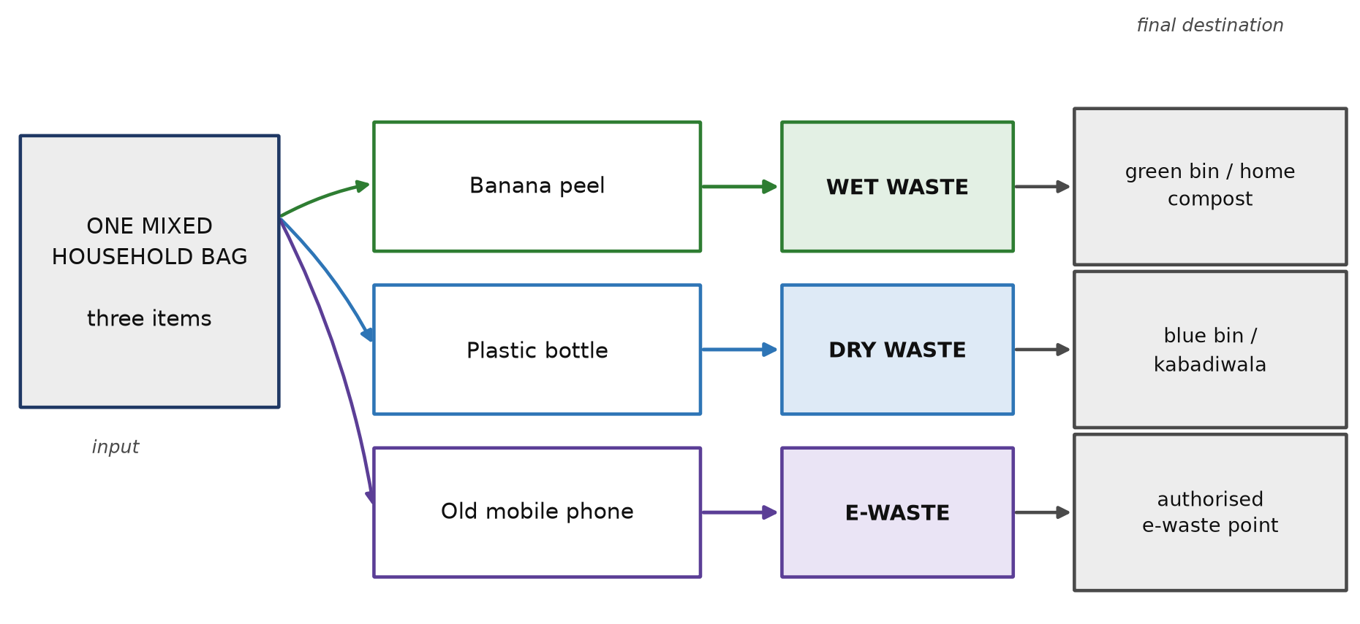
Fig. 9.1: Illustrative case study — three household items routed to three waste streams by the proposed logic (illustrative example, not the output of an executed application)

9.3 Item 1: banana peel
Table 9.1: Step-by-step trace for the input “banana peel” (illustrative)
Step | Value in this example
User input | banana peel
After normalisation | banana peel
Extracted keywords | banana, peel
Category scores | Wet Waste 1 (peel); banana not recorded in the illustrative vocabulary; all other categories 0
Selected category | Wet Waste
Confidence | Moderate — one of two keywords matched the recorded vocabulary
Displayed guidance | Wet Waste. Keep in a covered container, do not mix with plastic or paper, use the green bin or compost at home. Drain excess liquid before handing over.
Notes | The word “banana” would normally be added to the wet-waste vocabulary during review; the example is retained in this form to show how the confidence value behaves when only part of the input is recognised.

9.4 Item 2: plastic bottle
Table 9.2: Step-by-step trace for the input “plastic bottle” (illustrative)
Step | Value in this example
User input | plastic bottle
After normalisation | plastic bottle
Extracted keywords | plastic, bottle
Category scores | Dry Waste 2 (plastic, bottle); all other categories 0
Selected category | Dry Waste
Confidence | High — both keywords matched the dry-waste vocabulary
Displayed guidance | Dry Waste. Rinse off food residue, dry completely, flatten, and hand over with dry waste or sell to a scrap dealer.
Notes | The instruction sequence is not arbitrary. Rinsing precedes drying because a wet bottle cannot dry; drying precedes flattening because a flattened wet bottle traps moisture; and separation precedes handover because a bottle placed inside a bag of wet waste is lost.

9.5 Item 3: old mobile phone
Table 9.3: Step-by-step trace for the input “old mobile phone” (illustrative)
Step | Value in this example
User input | old mobile phone
After normalisation | old mobile phone
Extracted keywords | old, mobile, phone
Category scores | E-Waste 2 (mobile, phone); all other categories 0
Selected category | E-Waste
Confidence | Moderate to high — two of three keywords matched; “old” carries no material information
Displayed guidance | E-Waste. Delete personal data before handing over, do not break or open the device, keep the charger and accessories together, and hand over at an authorised e-waste collection point.
Notes | The data-deletion step appears before the disposal step deliberately. Once a device has left the household it can no longer be protected, and the privacy of the previous owner is as much a part of correct disposal as the recovery of the material.

9.6 Consolidated input and output
Table 9.4 consolidates the three traces in the form in which the system would present them. This is the table a user would see if the three queries were made one after another.
Table 9.4: Consolidated illustrative input–output table for the case study
Input | Category | Confidence | Channel | Disposal steps shown
banana peel | Wet Waste | Moderate | Green bin / home compost | Keep covered; do not mix with plastic or paper; drain excess liquid
plastic bottle | Dry Waste | High | Blue bin / scrap dealer | Rinse; dry; flatten; hand over separately from wet waste
old mobile phone | E-Waste | Moderate to high | Authorised e-waste point | Delete data; do not open the device; keep accessories together; hand over at an authorised point

9.7 Uncertain and potentially dangerous items
A design is best judged by how it behaves on difficult inputs rather than on easy ones. Table 9.5 therefore applies the same rules to five items a household may reasonably be unsure about, including two for which the correct behaviour is to decline to be definite.
Table 9.5: Illustrative behaviour on uncertain or dangerous items
Input | Category | Behaviour of the proposed system
used battery | Hazardous Waste | Special-handling block displayed: do not place in any bin; tape the terminals; wrap and mark; hand over at an authorised collection point. Recycling advice suppressed.
compact fluorescent lamp | Hazardous Waste | Classified as hazardous although the item is electrical, because the mercury content makes the safety instruction decisive. Instruction: keep intact, wrap, do not break, hand over at an authorised point.
expired medicines | Hazardous Waste | Do not flush and do not place in the wet bin; keep in the original packaging; hand over at an authorised collection point or as directed by the local body.
broken glass | Dry Waste, with a safety note | Category is dry waste, but the guidance begins with a warning to wrap the pieces in thick paper and mark the package, because the risk to the collector is immediate.
unknown or ambiguous item | Not recognised | The system states that it cannot identify the category, advises the user to follow the guidance of the concerned urban local body, and offers two examples of well-formed input.

9.8 Further worked examples
The same rules give sensible answers across the remaining categories. Tea leaves become wet waste; newspaper, glass jars and charger cables become dry waste and e-waste respectively; a paint tin with residue, used masks and torn bedsheets fall to hazardous, sanitary and textile waste in that order; cement lumps become construction and demolition waste; and thermocol packing becomes reject waste, to be placed in the residual bin and never burnt. What this shows is not that the rules are clever but that a small, well-chosen vocabulary covers a large share of everyday household items, and that the eight categories between them account for everything a household is likely to discard.

9.9 Observations from the case study
Four observations follow from working the examples through by hand.
1. The confidence value behaves sensibly on ordinary input. Complete, material-specific words such as “plastic” and “bottle” produce a high confidence; descriptive words such as “old” produce a moderate one. This is the intended behaviour, because it tells the user how much of their phrase the system actually understood.
2. The hard cases are not the exotic ones. No item in this case study is unusual, and yet two of the three required a design decision about precedence or about the order of instructions. The difficulty in household waste segregation lies in ordinary items, not in rare ones.
3. The instruction sequence carries as much value as the category. Telling a user that a bottle is dry waste does not produce a clean bottle; telling the user to rinse, then dry, then flatten, does.
4. The system is only as good as its vocabulary. In the first trace, the word “banana” was not recorded, which reduced the confidence even though the answer was correct. This is precisely the maintenance burden that Chapter 10 identifies as the principal limitation of a rule-based approach.

CHAPTER 10: ADVANTAGES AND LIMITATIONS

10.1 Introduction
A design report that lists only advantages is not a design report. This chapter states the case for the proposed system and then states, with the same specificity, the reasons it may fail.

10.2 Advantages
Table 10.1: Advantages of the proposed system
Advantage | Explanation
Answers the question the user actually has | The user does not ask which category a material belongs to; the user asks where a particular object should go. The design operates at the level of the object.
Available at the moment of decision | The answer is delivered in the same few seconds in which the decision is made, which is the only time it can influence behaviour.
Transparent and auditable | Every answer can be explained by a rule that a reviewer can read. There is no hidden model behaviour to be trusted on faith.
No data or infrastructure requirement | The design needs no training data, no server, no database and no network connection, and costs nothing to run once the knowledge base exists.
Protects the waste handler | The inclusion of wrap-mark-separate instructions for hazardous and sanitary waste addresses the safety of sanitation workers, who are the most exposed and least consulted group in the chain.
Language-inclusive | The vocabulary records Hindi, Hinglish and common misspellings, so a user is not excluded by the language in which the item is named.
Honest about uncertainty | The explicit refusal path means the system never presents a guess as a fact, which matters a great deal when the consequence may be an injury.
Extensible by non-programmers | Adding an item is an editorial task, not an engineering task, which allows a local body or a residents’ association to maintain the system in its own context.
Complements existing systems | It does not compete with collection, processing or the informal recycling economy; it improves the quality of what those systems receive.

10.3 Limitations
Table 10.2: Limitations of the proposed system
Limitation | Why it matters
Keyword matching does not understand meaning | An item described with a word that is not in the vocabulary will not be recognised, however obvious it is to a person. The system has no notion of synonymy, context or material composition.
Vocabulary maintenance is continuous | New products appear constantly and regional names vary. A knowledge base that is not maintained will slowly stop working, and its decay will be invisible.
Ambiguous and composite items remain difficult | Precedence rules resolve some conflicts but cannot resolve all of them. A medicine strip, a laminated pouch with a foil layer, or a battery inside a toy each require a judgement the design can only partly make.
Text-only input excludes some users | A user who cannot type, or who does not know the name of the material, cannot use the system. Voice and image input would broaden access but are outside the scope of this design.
Local variation limits generalisation | Bin colours, collection days and accepted fractions differ between urban local bodies. Guidance that is correct in one city may be wrong in another.
Behaviour change is not guaranteed | Knowing the right answer and acting on it are different things. A correct instruction reduces confusion but does not create a habit, and habits decay without reinforcement.
No measurement of effect | The design produces guidance but no evidence. Any claim about waste diverted or emissions avoided would require field measurement that this project does not include.
Advisory status | The system cannot determine legal compliance and must always defer to the local body, which limits how definitive its answers can be.

10.4 Mitigation of the identified limitations
Each limitation suggests a specific response, and several are cheap to address. Keyword matching can be improved without abandoning the approach by recording synonyms, regional names and morphological variants in the vocabulary. The maintenance burden can be reduced by publishing the knowledge base as an openly editable table with a version history and a fixed quarterly review. Composite items can be handled by expanding the precedence rules and by asking a single clarifying question when two categories score equally. Local variation can be absorbed by treating the container field as a per-city parameter rather than a fixed value. Habit decay can be countered by pairing the assistant with a plain weekly summary that reports progress without ranking or shaming. The absence of measurement can be remedied, as Chapter 11 sets out, by a small audit before and after introduction. And the advisory status of the guidance should be stated explicitly in every output rather than being assumed.

10.5 Assessment
Taken together, the advantages and limitations point to a narrow but real contribution. The system is not a substitute for municipal capacity, regulation or product redesign, and it will not by itself change how a city handles its waste. What it can do is remove a specific, well-evidenced obstacle at the first step of the chain — an uncertain resident at a bin — at almost no cost, without collecting anyone’s data, and without pretending to know more than it does. That is the appropriate ambition for a first design and the appropriate scope for an undergraduate project.

CHAPTER 11: SUSTAINABILITY AND EXPECTED IMPACT

11.1 Sustainability context
Waste management sits at the intersection of several sustainability concerns. It is a matter of climate, because buried organic waste emits methane and because recycling substitutes for energy-intensive primary production. It is a matter of public health, because burning waste degrades air quality and because sanitation workers are exposed to injury and infection. It is a matter of resource security, because landfilled material must be replaced by newly extracted material. And it is a matter of equity, because those who bear most of the harm rarely generate most of the waste. The 2030 Agenda expresses these concerns as goals and targets [17], and the proposed project aligns with those shown in Figure 11.1.
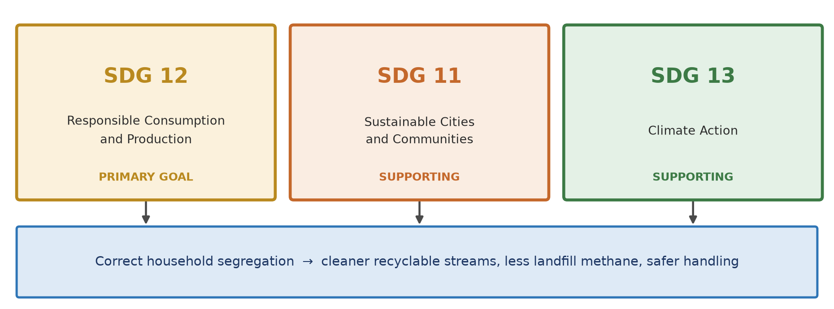
Fig. 11.1: Alignment of the proposed project with the United Nations Sustainable Development Goals
Table 11.1: Alignment of the project with the Sustainable Development Goals
Goal | Relevant target | How the proposed project contributes
SDG 12 — Responsible Consumption and Production | Target 12.5: substantially reduce waste generation through prevention, reduction, recycling and reuse | Primary alignment. Correct per-item guidance raises recycling and reuse and reduces contamination, which is the practical meaning of prevention and recycling at household level.
SDG 11 — Sustainable Cities and Communities | Target 11.6: reduce the adverse per capita environmental impact of cities, with attention to waste management | Supporting. Cleaner inbound streams improve the performance of collection and recovery systems and reduce dumping and open burning.
SDG 13 — Climate Action | Target 13.3: improve education and awareness on climate change mitigation | Supporting. The design explains, in plain language, why organic waste in a landfill is a climate problem, and it converts correct behaviour into a visible, if unmeasured, benefit.
SDG 3 — Good Health and Well-being | Target 3.9: reduce illness and death from hazardous chemicals and pollution | Indirect. Wrap-mark-separate instructions reduce the exposure of sanitation workers to sharps, chemicals and infectious material.

11.2 Environmental impact
The environmental case rests on three mechanisms, each well established in the literature even though this project measures none of them.
1. Methane avoidance. When organic waste is composted or digested rather than landfilled it decomposes aerobically and the methane that would have formed does not form. Because organic matter is the largest fraction of Indian household waste [6], and because methane has a much higher short-term warming potential than carbon dioxide [9], this is the largest environmental benefit available from better household segregation.
2. Material recovery. Clean dry waste can be recycled, and recycling displaces primary production. The benefit is largest for metals, where secondary production requires a small fraction of the energy needed from ore, and smallest for low-value materials. Contaminated material enjoys none of this benefit, which is why rinsing and drying is an environmental instruction and not merely a tidiness one.
3. Reduced open burning. When waste is separated and collected reliably, the incentive to burn it in the open falls. Open burning of mixed waste, particularly chlorinated plastics, releases compounds harmful to health and to air quality [6].

11.3 Social impact
The social dimension is at least as significant as the environmental one. Sanitation workers handle material that households have discarded, frequently without gloves and without warning. Sharps hidden in a mixed bag, a leaking cell, a broken tube light or an unwrapped sanitary pad are hazards created by the generator and borne by someone else. A household member who reads one clear instruction to wrap and mark an item is being asked to take responsibility for a risk that is currently transferred silently to another person. If the design achieves nothing else, it makes that transfer visible.
There is a second social benefit, less tangible but no less real. Waste rules are written in administrative language that most residents have never been taught to read. Restating the same obligation as “wrap it, mark it, hand it over separately” brings a civic duty within reach of a person who would never open a municipal notification.

11.4 Economic impact
Economically, the effect of better segregation is felt downstream. A recovery facility that receives a cleaner dry stream produces bales that sell at a higher price, because the buyer pays for material and not for moisture and contamination. Collection costs fall when wet waste is not carried mixed with dry waste, since weight and volume both reduce. And municipal expenditure on remediation — clearing dumped waste, extinguishing landfill fires, treating leachate — falls when less material reaches dumps. None of these effects has been quantified by this project, and any figure offered without measurement would be conjecture.

11.5 How the impact would be measured
A credible impact claim requires instrumentation that is designed before the intervention rather than after it. Four indicators are proposed, all of which can be collected by a student group or a residents’ association without specialist equipment.
The four indicators are the correct-sort rate, obtained by auditing household bins before and after introduction; the purity of the dry stream, obtained by inspecting and weighing a sample; the frequency of use, obtained from a locally kept count of queries; and the number of handler incidents, obtained from reports recorded by the collection crew. The first is the primary outcome, because it is the behaviour the design exists to change; the last is the indicator a purely environmental evaluation would omit, and its inclusion is what makes the evaluation consistent with the responsible AI commitments of Section 7.6.

11.6 Responsible deployment
Finally, the sustainability claim is conditional on how the design is deployed. The guidance must remain advisory and must always direct the user to the local body for any regulatory question; the knowledge base must be maintained, because a stale rule table gives confident wrong answers and is worse than no tool; and no data should be collected about households, because the value of the intervention does not depend on surveillance. A deployment that violated any of these conditions would not be the system this report describes.

CHAPTER 12: CONCLUSION
This report has documented the design of SwachhAI, an intelligent waste segregation and sustainable waste management assistant, developed as a documentation-based academic project following the AI for Sustainability Virtual Internship organised by 1M1B with the support of AICTE and in collaboration with IBM SkillsBuild.
The problem is specific and well evidenced. India generates a very large quantity of municipal solid waste, a majority of it organic, and only a minority of households separate it at source [1], [6]. The consequence is a chain of avoidable losses: methane from landfilled organics, recyclables destroyed by contamination, higher collection and processing costs, and preventable risks to the health of sanitation workers. Existing responses — posters, awareness drives, two-bin systems, municipal websites — are all reasonable, and none of them operates at the moment and in the form in which the household decision is actually made.
The design proposed in response is deliberately modest. It accepts the name of an item, normalises the text, matches keywords against a knowledge base organised around eight waste categories derived from the Solid Waste Management Rules, 2016, selects the best-scoring category, reports its confidence honestly, and returns a short, ordered set of disposal steps. For hazardous, sanitary and electronic items it substitutes a safety instruction that protects the person who will handle the waste. When it is not sure, it says so.
The report has presented the relevant technology at an introductory level — Python and its basic constructs, rule-based classification, the fundamentals of artificial intelligence, responsible AI and the role of digital solutions in sustainability — and has been careful to distinguish what was studied during the internship from what the original submission described and from what this report proposes. It has presented a five-layer conceptual architecture, a classification flowchart, a data flow diagram, a module decomposition and a documented case study in which three ordinary household items were traced through the design by hand.
The honest limits of the work have been stated throughout rather than at the end. No software was developed, no model was trained, no database was created and no system was tested or deployed. Every table of results is an illustration of intended behaviour derived from stated rules, and none of it is a measurement. The design also carries substantive weaknesses: keyword matching does not understand meaning, the knowledge base requires continuous maintenance, composite items remain difficult, and no claim about behaviour change can be made without field evaluation.
Within those limits, three conclusions seem defensible. First, the most useful contribution of a computational approach to household waste segregation may be the least technically elaborate: a correct, item-level answer delivered at the moment of decision, in ordinary language, with an honest admission of uncertainty. Second, transparency and predictability are not compromises accepted for the sake of simplicity but positive requirements where a wrong answer can injure a person. Third, separating what was learned, what was proposed and what was demonstrated is itself part of the contribution, because a design that overstates itself cannot be safely improved by anyone else.

CHAPTER 13: FUTURE SCOPE

13.1 Introduction
The design described in this report is a starting point, and the most useful thing that can be said about it is what should happen next. The directions below are ordered by how much they depend on the present design being correct.

13.2 Near-term directions
1. Completion of the knowledge base. The first priority is to expand the vocabulary from the illustrative entries in this report to a properly reviewed set covering several hundred items, with regional and Hindi names recorded alongside English ones.
2. Independent expert review. Each category’s instructions should be reviewed by someone with practical responsibility for waste handling — a municipal solid waste officer, a material recovery facility operator or a sanitation workers’ representative — before any of it is shown to a user.
3. Localisation of the container field. Bin colours, collection days and accepted fractions differ between urban local bodies and must be supplied per city rather than fixed in the design.
4. A small controlled pilot. A single hostel block or housing society provides a realistic test of whether the guidance is used and whether it changes what is placed in the bins.

13.3 Medium-term directions
Table 13.1: Medium-term directions and their purpose
Direction | Purpose | Dependency
Voice input in Hindi and English | Include users who cannot type, and users who know the item by its spoken name only | Speech recognition; a vocabulary of spoken item names
Image input for the item | Allow the user to photograph the object instead of naming it | A trained vision component and a labelled dataset — outside the scope of this report
Multilingual output | Deliver the guidance in the language the user reads most comfortably | Translated guidance reviewed by native speakers
Household progress summary | Sustain the behaviour by showing a factual weekly summary without ranking or shaming | Local recording of counts only; no personal data
Ward-level aggregation | Give the local body anonymous, aggregate information about which items are most often mis-sorted | Explicit consent, aggregation at a minimum cohort size, and a privacy design reviewed before collection

13.4 Long-term directions
Three longer-term directions follow from the design as it stands, and each changes the nature of the system rather than merely extending it.
• Integration with collection services. If a local body publishes its collection calendar, the assistant can tell a household not only which stream an item belongs to but when that stream will next be collected. This converts a classification tool into a small planning tool.
• Retrieval-grounded question answering. The original internship submission described an assistant that answers questions about waste rules by retrieving passages from a curated corpus of official documents and citing them, and refusing when the passages do not contain the answer [19]. Such a design would answer the questions this project cannot: why a rule exists, what applies in a particular city, and what the regulation actually says. It requires careful grounding, citation and refusal behaviour, and it is a substantially larger engineering undertaking than the classifier described here.
• Bidirectional link with the informal sector. Scrap dealers and informal collectors already perform most of India’s recycling. A version of the assistant that told a household what a particular type of waste is currently worth, and connected that to a local collector, would align the environmental benefit with an economic one. Any such design would have to treat those workers as partners with rights and not as a resource to be optimised.

13.5 Research directions
Beyond engineering, the problem raises questions that need field study rather than code. What actually changes household behaviour: the accuracy of the answer, the speed with which it is delivered, or the fact that someone is asked the question at all? Does an explicit statement of uncertainty increase or decrease trust? Does guidance that foregrounds the safety of the sanitation worker change behaviour more than guidance that foregrounds environmental benefit? Each could be tested with a modest controlled study, and each would be more valuable to the field than another classifier.

13.6 Concluding remark
The direction of travel this report recommends is towards less machinery and more responsibility: a smaller system, more carefully reviewed, with a knowledge base maintained by the people who understand local practice, and with claims that are measured rather than modelled. A waste segregation assistant does not need to be intelligent in order to be useful. It needs to be right, it needs to be available at the right moment, and it needs to know when to stop.

REFERENCES
[1] Ministry of Environment, Forest and Climate Change, Government of India. Solid Waste Management Rules, 2016. Gazette of India, 2016.
[2] Ministry of Environment, Forest and Climate Change, Government of India. E-Waste (Management) Rules, 2022. Gazette of India, 2022.
[3] Ministry of Environment, Forest and Climate Change, Government of India. Battery Waste Management Rules, 2022. Gazette of India, 2022.
[4] Ministry of Environment, Forest and Climate Change, Government of India. Construction and Demolition Waste Management Rules, 2016. Gazette of India, 2016.
[5] Ministry of Environment, Forest and Climate Change, Government of India. Plastic Waste Management (Amendment) Rules, 2021. Gazette of India, 2021.
[6] Central Pollution Control Board, Government of India. Annual reports and guidance notes on solid waste management, including notes on disposal practice and landfill fires. New Delhi.
[7] Ministry of Housing and Urban Affairs, Government of India. Swachh Bharat Mission (Urban) 2.0 — Guidelines and citizen guidance on source segregation and material recovery. New Delhi, 2021.
[8] United Nations Environment Programme. Food Waste Index Report. Nairobi, 2021.
[9] Intergovernmental Panel on Climate Change. Sixth Assessment Report (AR6), Working Groups I–III. Cambridge University Press, 2021–2023.
[10] Bureau of Indian Standards. IS 14534: Guidelines for Recycling of Plastics. New Delhi.
[11] M. Lutz. Learning Python. 5th edition. O’Reilly Media, 2013.
[12] S. Russell and P. Norvig. Artificial Intelligence: A Modern Approach. 4th edition. Pearson, 2021.
[13] United Nations Educational, Scientific and Cultural Organization. Recommendation on the Ethics of Artificial Intelligence. Paris, 2021.
[14] NITI Aayog, Government of India. Responsible AI for All — Approach Document for India. New Delhi, 2021.
[15] Central Public Health and Environmental Engineering Organisation, Ministry of Housing and Urban Affairs. Manual on Municipal Solid Waste Management. New Delhi.
[16] Ministry of Housing and Urban Affairs, Government of India. Swachh Survekshan and urban waste composition assessments. New Delhi.
[17] United Nations General Assembly. Transforming our World: the 2030 Agenda for Sustainable Development (A/RES/70/1). New York, 2015.
[18] 1M1B (One Million for One Billion). AI for Sustainability Virtual Internship — programme learning materials on artificial intelligence, responsible AI and sustainability. 2026. (Programme material; not reproduced in this report in accordance with the confidentiality terms of the internship.)
[19] M. R. Ansari. SwachhAI — AI for Sustainable Waste Management: Final Project Deliverable, 1M1B AI for Sustainability Virtual Internship in collaboration with IBM SkillsBuild and AICTE. Submitted 14 September 2026.
[20] 1M1B. AI for Sustainability Virtual Internship — Internship Offer Letter and completion certificates issued to the author, including AICTE Internship ID INTERNSHIP_17828984086a44dee80acf6. 2026. (Used for verification of internship details only.)
Note on sources. The regulatory instruments listed above are the primary sources for the stream definitions and generator duties used in this report. Statistical statements are attributed to the agency reports in which they are published and are described as approximations where the underlying estimates vary between sources. Reference [19] is the author’s own internship submission and is cited as the origin of the SwachhAI concept.

APPENDICES

Appendix A: Evidence of internship learning
The two certificates reproduced below were issued through the IBM SkillsBuild learning platform for completion of the assigned learning plans during the internship. They are included as evidence of the learning component of the programme and are reproduced without alteration.
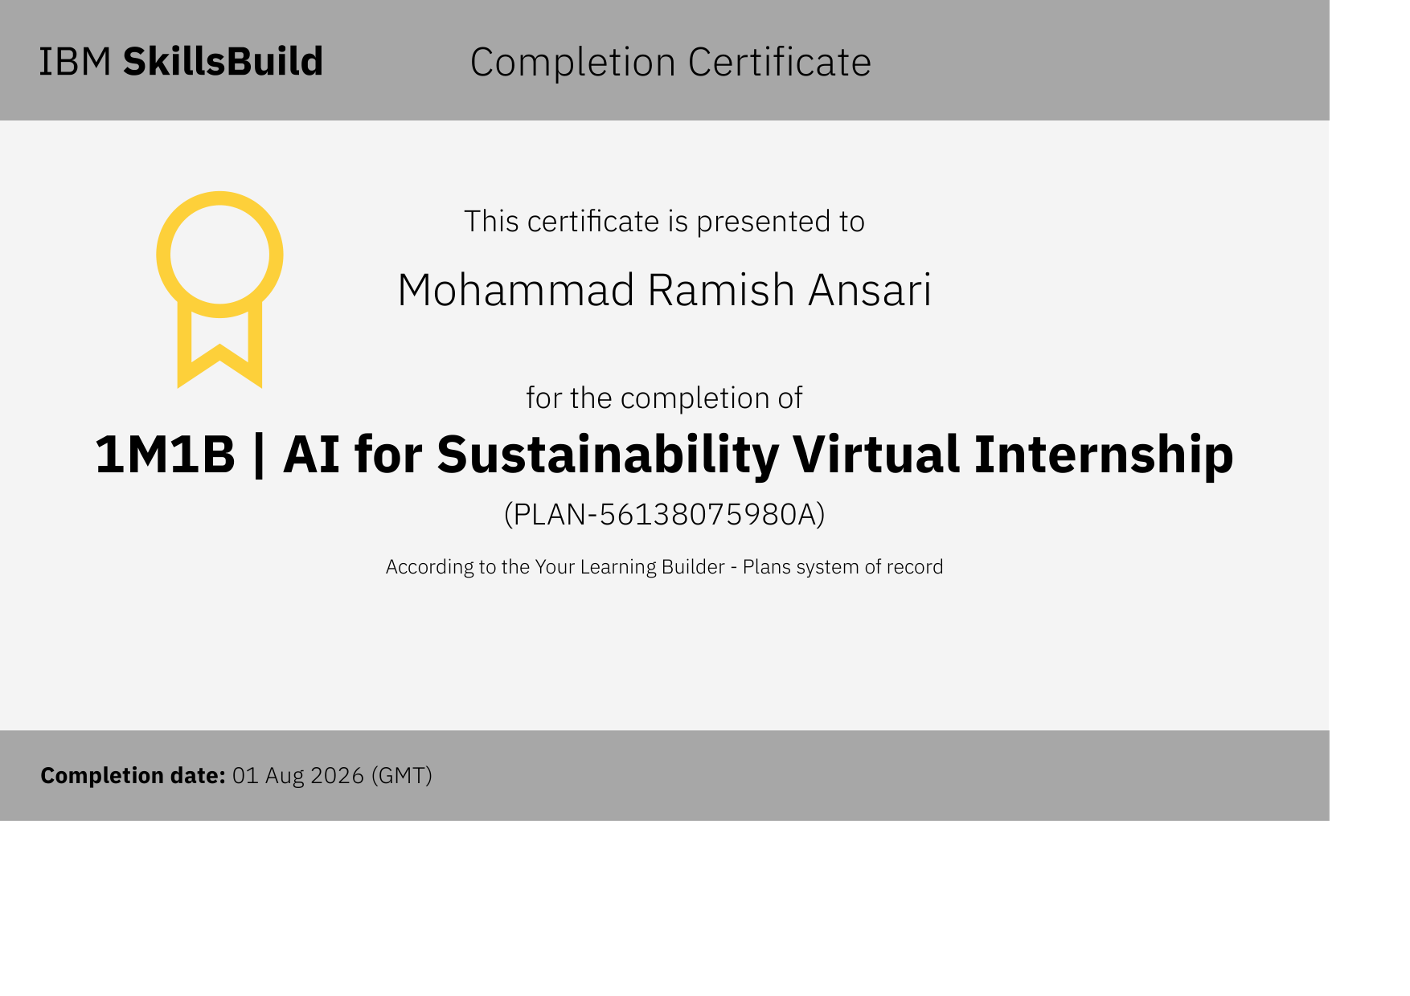
Fig. A.1: IBM SkillsBuild completion certificate for the 1M1B AI for Sustainability Virtual Internship learning plan (completion date 01 August 2026)
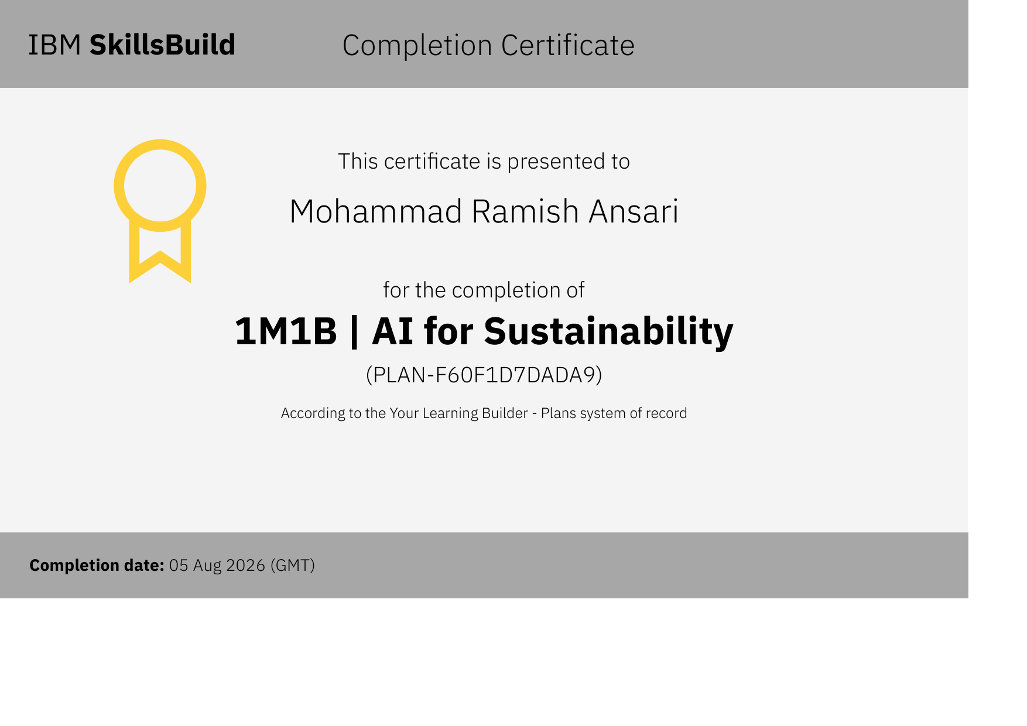
Fig. A.2: IBM SkillsBuild completion certificate for the 1M1B AI for Sustainability learning plan (completion date 05 August 2026)

Appendix B: Checklist of information to be completed before submission
The following items were not available at the time of preparation and are marked with a placeholder in the body of the report. They should be completed by the student in consultation with the department before the report is bound.
Table B.1: Placeholder fields to be completed
Field | Where it appears | Status
Roll number / registration number | Cover page, declaration, acknowledgement | To be filled from the university record
Name and designation of faculty guide | Acknowledgement | To be filled
Name of the Head of the Department | Acknowledgement | To be filled
Date of submission | Declaration | To be filled at the time of submission
Signatures of student and faculty guide | Declaration and certificate pages | To be signed in ink after printing
Month and year on the cover page | Cover page | To be confirmed by the department

